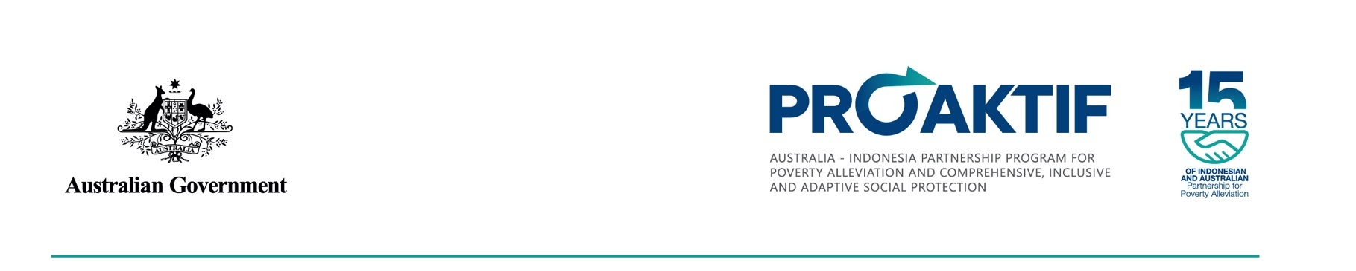

Inclusive social protection for persons with disabilities in Indonesia: A rapid review of evidence

Prepared by the Center for Inclusive Policy
and the Inclusion Advisory Group, CBM Global
20 June 2025 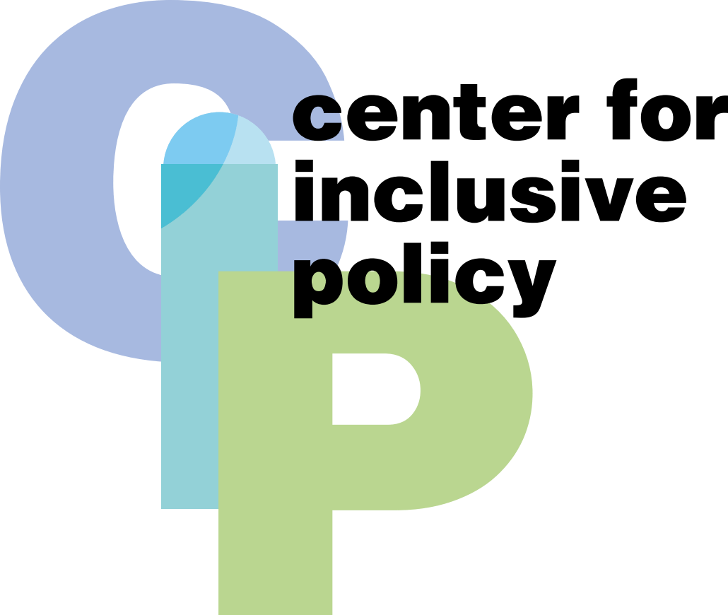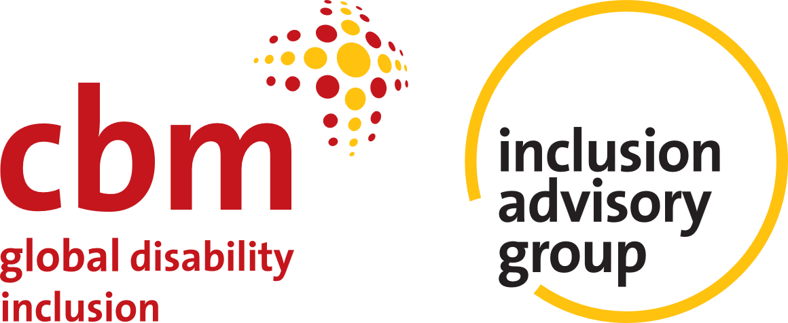

Since 2010, Indonesia has partnered with Australia for poverty alleviation through a series of initiatives: the Poverty Reduction Support Facility (PRSF 2010–2015), Towards a Strong and Prosperous Indonesian Society Program (MAHKOTA 2015– 2023), and The Australia-Indonesia Partnership Program for Poverty Alleviation and Comprehensive, Inclusive and Adaptive Social Protection (PROAKTIF 2023– 2025). In 2025, we celebrate this long-standing collaboration that has helped to shape the policy landscape, leading to tangible improvements for households.
Acknowledgements: This paper was authored by Daniel Mont and Aisyah Ardani (Center for Inclusive Policy), and Cucu Saidah, Ida Putri and Asahel Bush (Inclusion Advisory Group, CBM Global).
Table of Contents
Executive Summary 6
Introduction 12
Study methodology 15
Limitations 16
01. Inclusive Social Protection for Persons With Disabilities 17
02. Rapid Review of Evidence 23
Social protection for persons with disabilities in Indonesia: a rapid desk review 24
Prevalence of disability 24
Persons with disabilities and extra cost 28
Persons with disabilities and the poverty cycle 29
Social Protection Programs for Persons with disabilities 36
Educational Support 42
Health Protection Programs 43
Employment Support 44
Experiences of persons with disabilities with social protection in Indonesia 46
Overall experience of persons with disabilities and social protection 47
Key issues reported by persons with disabilities 49
Suggestions made by focus group discussion participants 52
03. International Examples 54
South Africa 55
France 56
Armenia 58
Thailand 59
Philippines 60
04. Discussion and Recommendations 62
Annexes 75
Annex 1: References 75
Annex 2: Focus group discussions 80
Annex 3: Selected annotated bibliography 84

Copyright Protected by Law © 2025 PROAKTIF
This publication is supported by the Government of Australia through the PROAKTIF Program (The Australia-Indonesia Partnership Program for Poverty Alleviation and Comprehensive, Inclusive and Adaptive Social Protection).
Copyright in the whole and every part of this document belongs to PROAKTIF and may not be used, sold, transferred, copied or reproduced in whole or in part in any manner or form or in or on any media to any person other than by agreement with PROAKTIF. The findings, interpretations, and conclusions expressed in this publication do not reflect the views of the Government of Indonesia or the Government of Australia. PROAKTIF does not and shall not assume any responsibility or liability whatsoever to any third party arising out of any use or reliance by any third party on the content of this document.
PROAKTIF is supported by the Australian Government and implemented by DT Global.

Executive Summary
This report reviews the principles of inclusive social protection for persons with disabilities and how they can inform policy developments in Indonesia. It presents a rapid summary of evidence to generate up-to-date insights, based on Indonesia’s commitments and international best practice, that can inform a context-specific program of work to progress social protection for persons with disabilities. Findings and recommendations are based on a desk review, focus group discussions with Indonesian disability representatives and consideration of comparative international country examples.
This report consists of four sections. The first provides a framework for inclusive social protection for persons with disabilities. The second presents evidence drawing from a rapid desk review of social protection for persons with disabilities in Indonesia and focus group discussions with organisations of persons with disabilities (OPDs) in Indonesia. The third section provides a brief look at how five countries are addressing the delivery of social protection for persons with disabilities. The final section presents analysis of key knowledge gaps relating to social protection and persons with disabilities in Indonesia, and recommendations for how these gaps can be addressed with reference to opportunities for short- and long-term policy reform. A reference list and annotated bibliography are included as annexes.

Inclusive social protection
The core components of inclusive social protection represent a move away from a charity-based model that merely provides a minimum level of income, to a set of policies that also enable increased participation in the economic and social lives of the community. These are:
- Breaking the link between “incapacity to work” and the receipt of disability benefits.
- Moving from institutionalized care to support for independent living in the community.
- Moving beyond a one-size-fits-all approach, to one that takes into account the full variety of extra costs associated with diverse disabilities.

Overview of persons with disabilities and social protection in Indonesia
The national prevalence rate of persons with disabilities in Indonesia is 6.42%, but is strongly associated with age. Disability is also associated with poverty, although official statistics underestimate the impact of disability on poverty, by not addressing disability costs. For example, the poverty rate for households having members with moderate or severe disabilities is about 16% compared to roughly 9% for households with no disability, but once extra expenditures related to disability are accounted for, the effective poverty rate for households with members with moderate or severe disabilities exceeds 25%.
Gaps also exist when it comes to education and employment. For example, only 9.26% of children aged 7-12 without disabilities are not attending school compared to 18.95% of their peers with disabilities. The gap is even more significant among 13–15-year-olds, with 9.26% of non-disabled children out of school compared to 31.745 for those with disabilities. In terms of employment, 44.5% of working age adults with disabilities are employed which is significantly less than the 70.01% employment rate for those without disabilities.
A variety of social protection programs exist that are designed across the life cycle, some for the general population and some targeted specifically at persons with disabilities. There are also specific programs for working age adults that focus on training, and an educational cash transfer program for school aged children. Some programs are means tested, while others benefit the whole population.
Data show that the percentage of persons with disabilities receiving non-disability-specific benefits is far below the percentage of their counterparts without disabilities. There is also a lack of support for older persons with disabilities, which is the group most at risk of poverty. While it true that the number of recipients of cash benefits with severe disabilities increased dramatically from 2006 to 2018, the number of recipients is still low compared to the overall population of persons with disabilities at only 0.1%. The same is true of health benefits. Over 13% of poor persons with disabilities are not enrolled in health protection programs.

Experiences of persons with disabilities in social protection programs
Awareness of rights to social protection remain low among persons with disabilities in Indonesia, and many persons with disabilities report being unclear about various schemes, eligibility criteria, benefit levels and/or complaint mechanisms. Overall, access to social protection remains low for persons with disabilities, especially in rural areas and among those who are not connected with organisations of persons with disabilities which attempt to facilitate access.
Problems of access are more acute among women, ethnic minorities, and those with invisible disabilities who often face inappropriate questions by administrators. Persons with disabilities report a range of issues with determination processes: disability support needs are not considered as parameter for determining eligibility; household-level information does not reflect the barriers and needs of individuals with disabilities; and people who are known by administrators or village leaders are more likely to be included.
Those who are already included in the social protection program face challenges to accessing funds due to inaccessible processes and facilities or lack of personal assistance provided. Persons with disabilities also report problems with transparency, relating to the amount of benefits they receive, how eligibility is determined, and the conditions under which benefits can be deactivated.
Persons with disabilities interviewed suggested the following:
- Improve disability awareness among community leaders and system administrators.
- Provide information about programs and criteria in accessible formats.
- Build a one-stop disability data system to assess eligibility of persons with disabilities.
- Simplify bureaucracy and ensure accessibility in registration and receipt of benefits.
- Consider the extra costs of disability in eligibility determination.

International examples
Brief international examples are provided from five different countries (South Africa, France, Armenia, Thailand, and the Philippines), summarising issues related to the delivery of social protection benefits to persons with disabilities and highlighting key challenges, approaches and innovations involved. The examples focus mainly on the determination system in each country and how social protection benefits are related to means testing and/or the ability to work. Collectively, the examples have been selected to illustrate a diverse range of system features that are potentially relevant to Indonesia and can inform future policy directions.

Discussion and recommendations
It is important for Indonesia to move more towards a model of social protection that enables equal protection for persons with disabilities, rather than being perceived simply as an anti-poverty program. As the extra costs associated with disability come in part from barriers in the environment, Indonesia needs better information on how those barriers can create those costs (e.g., lack of accessible transportation) so that they can be reduced. Indonesia has made some progress in the design of inclusive programs, with some programs supporting education and training for employment for persons with disabilities, and therefore not completely associating disability with the inability to work. However, existing non-cash benefit programs are not based on a rigorous analysis of the goods and services required by persons with disabilities, and poverty-targeted programs make no adjustments for the extra costs associated with disability. The perspectives of persons with disabilities themselves are essential to understanding barriers to accessing general social protection programs and to shaping more effective and sustainable change that contributes to the realisation of the rights for persons with disabilities in Indonesia.
To plan for future policy reforms to strengthen inclusive social protection for persons with disabilities in Indonesia, there is a need to address key knowledge gaps relating to:
- Specific gaps in the social protection regulatory framework and system that need to be addressed, e.g. through regulatory gap analysis or policy mapping.
- The distribution of types of disability and extent of support needs throughout the population, and how this is associated with personal and household characteristics.
- The extent to which persons with disabilities continue to live in residential institutions in different parts of Indonesia, the resourcing of these institutions, the experiences of persons with disabilities within them, and the drivers towards institutional care at household, community and policy level.
- The goods and services needed by persons with different types and degrees of disability, and how they change over the life cycle.
- The cost and availability of goods and services in different geographical contexts, and how models of delivery can be best suited to local contexts.
- Relevant international examples of systems for individualized disability assessment that are based on barriers and support requirements.
- The barriers that diverse persons with disabilities experience at each stage of social protection programming, and their perspectives on opportunities to strengthen the system.
- The extent to which persons with disabilities in Indonesia maintain personal autonomy, choice, privacy and control over social protection benefits, including within individual households.
- The use of consultative processes and methodologies that feature the meaningful involvement of diverse persons with disabilities in efforts to address the knowledge gaps identified above.

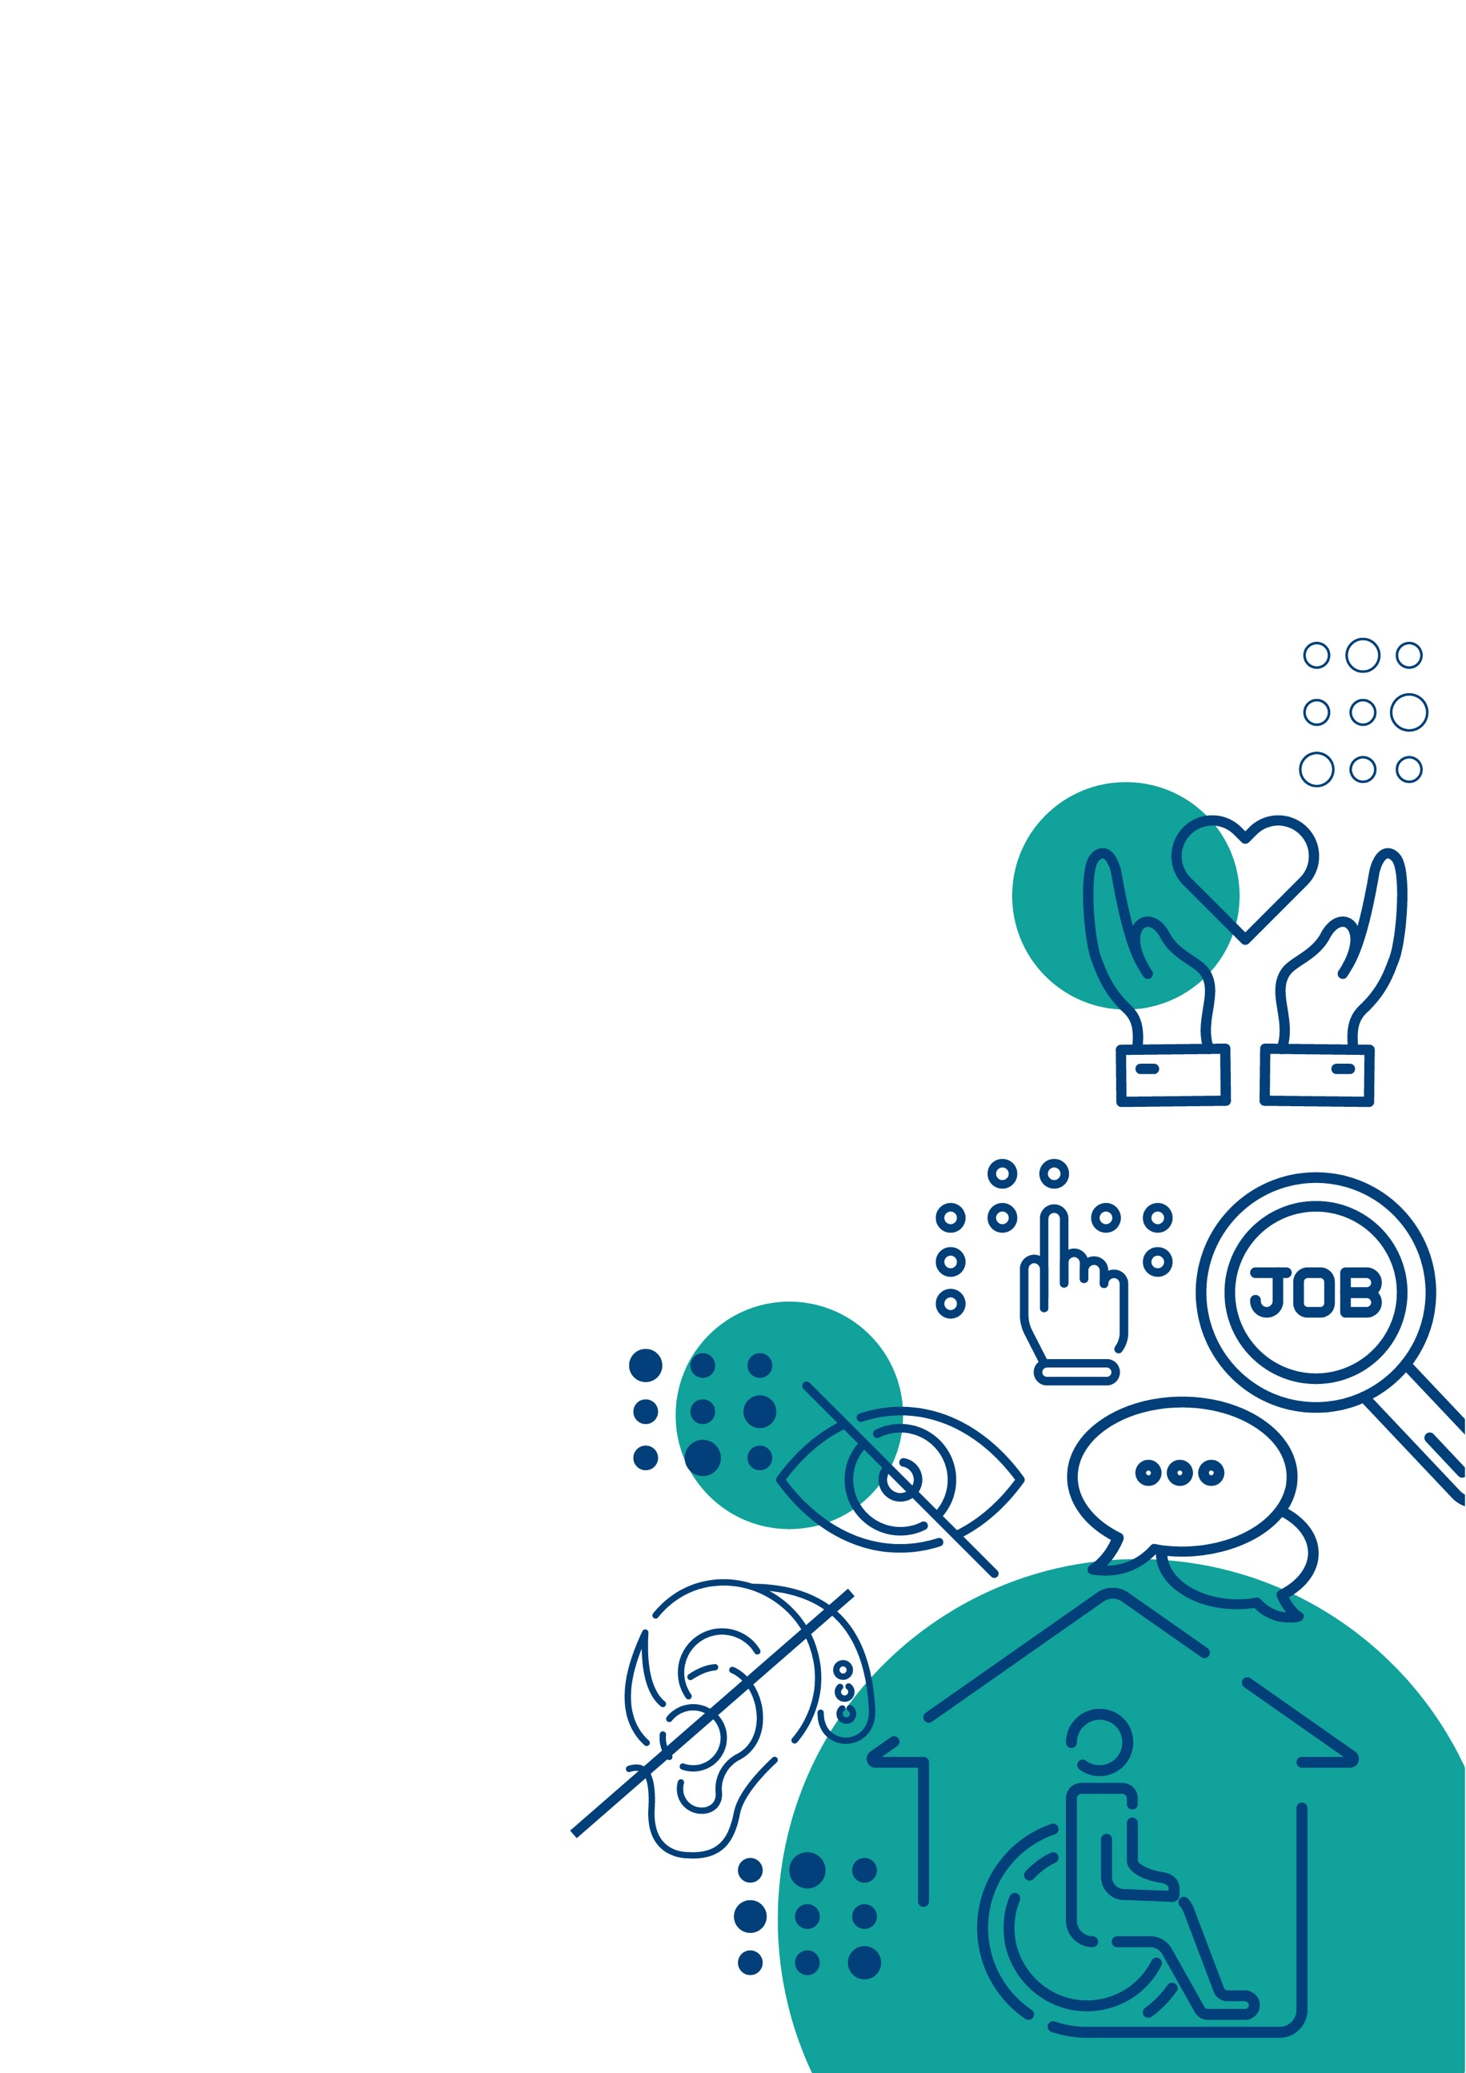

Introduction
Global evidence emphasizes that social protection systems are an essential element in realizing the rights of persons with disabilities, providing greater access to essential services, financial security, and opportunities for full participation in society. A robust and inclusive social protection system reduces barriers, promotes dignity, and allows due alignment with the CRPD, supporting equal opportunities and independence for persons with disabilities.
Based on Susenas data (2023), it is estimated around 7% of the total population in Indonesia has a disability, with the largest cohort comprising adults aged 60 years or above, and a higher proportion of women than men. Indonesia ratified the United Nations Convention on the Rights of Persons with Disabilities (CRPD) on 3 November 2011 and subsequently developed various policies committing to promote, protect and ensure the full and equal enjoyment of all human rights and fundamental freedom by all persons with disabilities. The Law No. 8/2016 on Persons with Disabilities and the government regulations (Peraturan Pemerintah/PP), include provisions of social welfare services, reasonable accommodation in education facilities, and service unit on disability and employment, and habilitation and rehabilitation services.
Indonesia’s social protection system includes targeted social assistance provisions for persons with disabilities (e.g. Asistensi Rehabilitasi Sosial (ATENSI)), as well as various other social protection programs for which persons with disabilities are eligible based on non-disability-related criteria. These latter programs include cash transfers for health and education, food in-kind transfers, and health and employment insurance schemes, among others.
Nonetheless, social protection coverage for persons with disabilities in Indonesia remains low, with benefits received unlikely to meet the true costs associated with having a disability. Moreover, it provides equal financial benefits to all eligible persons with disabilities, while the range of needs (and associated costs) for persons with disabilities can vary significantly by type and degree of disability.
Based on initial findings in 2018, the National Team for the Acceleration of Poverty Reduction (TNP2K) Policy Team, has proposed that Government of Indonesia (GoI) increase coverage and strengthen social protection programs for persons with disabilities. However, evidence and analysis on disability and social protection in Indonesia – including academic research, GoI analysis, reports from development partners, and reports from community groups – remain scattered. Furthermore, in the last 5-7 years there have been significant developments in the global body of evidence on social protection for persons with disabilities. During this timeframe, several middle-income countries have introduced disability-inclusive social protection reforms, generating lessons and examples which may be highly relevant to the context of Indonesia. There is a need to collate and analyse these evidence sources to generate up-to-date insights, based on Indonesia’s commitments and international best practice, that can inform a context-specific program of work to progress social protection for persons with disabilities.
This rapid review of evidence responds to these challenges by consolidating and organizing existing evidence on social protection for persons with disabilities in Indonesia, analysing this evidence through a lens of international best practice as adapted to the Indonesian context, and drawing from relevant international examples of systems reform.
This process aims to support PROAKTIF’s Policy Support Team of the Coordinating Ministry for Community Empowerment (Kemenko PM) and its GOI partners, in strengthening Indonesia’s social protection framework for persons with disabilities by informing their future strategies, research priorities and workplan initiatives. It aims to provide recommendations on evidence gaps and short- and longer-term opportunities for system and policy reform, to inform efforts to build a social protection framework in Indonesia that includes persons with disabilities, aligns to international commitments and best practice and is adapted to the context of Indonesia.
This report consists of four sections. The first provides a framework for inclusive social protection for persons with disabilities. The second presents evidence drawing from a rapid desk review of social protection for persons with disabilities in Indonesia and focus group discussions with organisations of persons with disabilities (OPDs) in Indonesia. The third section provides a brief look at how five countries are addressing the delivery of social protection for persons with disabilities. The final section presents analysis of key knowledge gaps relating to social protection and persons with disabilities in Indonesia, and recommendations for how these gaps can be addressed with reference to opportunities for short- and long-term policy reform. A reference list and annotated bibliography are included as annexes.

Study methodology
This study seeks to answer the following key questions:
- How can the latest global evidence and best practice, including those informed by Indonesia’s international commitments, guide analysis and understanding of inclusive social protection for persons with disabilities?
- What is the existing evidence on the situation of persons with disabilities vis-à-vis Indonesia’s social protection system?
- What examples of reforms from other countries could inform efforts to enhance access, equity and coverage for persons with disabilities in Indonesia’s social protection system?
- What are the key knowledge gaps relating to social protection and persons with disabilities in Indonesia, and how do they relate to opportunities for short- and long-term policy reforms?
A guiding analytical framework for this evidence review was produced by the review team drawing from key global commitments and guidance relating to inclusive social protection for persons with disabilities. This guided two primary evidence collection processes: a rapid desk review and focus group discussions (FGDs).
The rapid desk review was undertaken to provide an overview of inclusive social protection and the situation of persons with disabilities in Indonesia. The review began with core materials provided to the review team by representatives of the PROAKTIF (The Australia-Indonesia Partnership Program for Poverty Alleviation and Comprehensive, Inclusive and Adaptive Social Protection) and PROSPERA (The Australia Indonesia Partnership for Economic Development) programs, which were then supplemented with additional materials sourced from a targeted online search.
Three FGDs were held in March 2025 with a total of 28 OPD representatives, representing 21 OPDs from across Indonesia. These explored the experiences and perspectives of persons with disabilities who had been able to access social protection benefits, as well as those who had not been able to access them. Details of the FGD process are provided in Annex 2.
For the country examples, the basis of the review began with the extensive work in this area previously undertaken by the Center for Inclusive Policy. This was then validated and expanded by further desk review.

Limitations
Note that the rapid nature of this study presents several limitations. The desk review was targeted, rather than comprehensive, meaning that there is likely additional relevant evidence available that was outside of its scope. This includes evidence on topics that are separate from, but closely related to, social protection, including evidence on health, education, employment, economic empowerment and the causes of poverty and discrimination for persons with disability.
The scope of focus group discussions was also limited. Although a range of OPDs were engaged, representing diverse groups of persons with disabilities from different parts of Indonesia, this evidence provides only a partial snapshot of the context. Data collection with individual persons with disabilities and other system stakeholders was not undertaken in this study.
Finally, this rapid study has identified key evidence sources and knowledge gaps, providing a snapshot of the current context in Indonesia, suggesting relevant international examples and highlighting priorities for future evidence collection. Additional evidence will be required to develop recommendations on specific policy reforms.



Inclusive Social Protection for Persons With Disabilities
According to the Social Protection Interagency Cooperation Board (SPIAC-B), social protection is “a set of policies and programs aimed at preventing or protecting all people against poverty, vulnerability and social exclusion throughout their life cycle, with a particular emphasis towards vulnerable groups.” As such, these policies have three key goals: poverty alleviation, income security, and the protection against shocks. Poverty alleviation is generally addressed through financial assistance to individuals or households living below the poverty line or facing extreme hardship. This can take the form of cash transfers, food aid, or subsidies for essential services (e.g., health, education, and housing). Policies promoting income security aim to ensure a minimum level of income for individuals who are unable to work due to age, disability, or illness, or those who have lost their jobs. This includes old-age pensions, unemployment benefits, and disability support. And finally, policies designed to protect against shocks and safeguard individuals from events such as job loss, illness, or natural disasters.
These policies are particularly important for persons with disabilities as they are disproportionately poor as the result of barriers to education and employment. However, policies are often not designed to account for the reality of living as a person with a disability and thus can be ineffective in meeting their goals.
Broadly speaking, when it comes to poverty alleviation many social protection programs do not account for the extra costs incurred by persons with disabilities, and they can be very significant. These include both disability specific costs, such as assistive technology and personal assistants, as well as increased general costs, such as medical care and transportation. The poverty line (or means test) does not accurately reflect their lived reality. Even people with incomes above the poverty line can effectively be living in poverty because of the extra necessities they need to purchase beyond the bundle of food, shelter and other necessities that a standard poverty line is supposed to represent. Moreover, these costs can vary significantly across individuals based on the type and nature of their disability and the context within which they live. To be effective, social protection policies need to account for this.
In terms of income security, one problem with many disability benefit programs is that they tie the receipt of benefits to the inability to work. This creates a disincentive to work and undermines the ability of persons with disabilities to generate a sustained livelihood. And when it comes to protection against shocks, often the goal of social protection programs is to overcome a temporary situation – for example a spell of unemployment -- and not adjustment to a new permanent situation like disability that comes with new barriers to livelihood generation. That is, there is no effort to bridge persons between their past reality to a situation that comes with new challenges. For example, after a spell of unemployment (or the rebuilding of a house damaged in a storm) a person goes back to their previous situation. A person experiencing a spinal cord injury now has the additional ongoing expense of wheelchair maintenance, rehabilitation, inaccessible transportation, etc. which can represent a much different situation with additional expenses and barriers to participation than what existed before the shock.
These concerns are embodied in the United Nations Convention on the Rights of Persons with Disabilities (CRPD), which Indonesia has ratified. Article 28 of the CRPD states that persons with disabilities should have an adequate standard of living on an equal basis with others, in part through equal access to social protections aimed at poverty including through the provision of quality disability related services and devices. This also relates to Article 19 that affirms the right to live independently in the community, as well as to articles pertaining to the provision of health and education services.
The issue is how to achieve these goals. According to the Joint Statement on inclusive social protection, a multistakeholder process facilitated by the ILO and the International Disability Alliance, the role of disability inclusive social protection entails:
- Breaking the link between “incapacity to work” and the receipt of disability benefits. Social protection benefits should support one’s ability to generate a livelihood and not provide a disincentive to work. A number of countries, including Fiji, Mauritius, and Thailand, have structured benefits this way. Instead of being seen as wage replacement, disability benefits can be constructed to cover the extra costs of disability, including those associated with work, so that persons with disabilities can participate in society on an equal basis as their peers without disabilities.
- Moving from institutionalized care to support for living in the community. The CRPD states that segregated institutions and residential facilities violate the rights of persons with disabilities. States should provide support – be it through cash, concessions, the provision of goods and services, or other means – that enable a person to live independently.
- Moving beyond a one-size-fits-all approach. Recent studies have shown that the type and extent of supports needed by persons with disabilities varies widely. The number of countries undertaking studies examining those costs has grown. Indonesia has conducted such a study, as have Georgia, India, Namibia, Fiji, Uzbekistan, Saudi Arabia, Armenia and others. They all reveal that a single cash benefit is not well suited to effectively and efficiently meet those needs. Often a coordinated suite of programs and approaches is needed.
There are two basic approaches to reducing the extra costs experienced by persons with disabilities. One is to provide the resources and support needed. The other is to remove barriers in the environment that can worsen those costs (e.g., inaccessible public transportation). Both strategies are needed.
Providing for the needs of persons with disabilities can be done through a variety of programs, but an essential component is developing in-kind programs that can deliver necessary goods and services that are hard to obtain or not available. Studies have shown that the biggest drivers of extra costs are personal assistance, medical care, transportation, and assistive technology. Providing these can more efficiently target the diverse needs of persons with disabilities, however the range of goods and services required is broad so there will always be a need for a cash benefit.
To deliver services, though, an assessment of support needs is important. As stated in the Joint Report, “Solid information on the type and extent of goods and services required by persons with disabilities is needed to deliver social protection goods and services and even budget and plan for their delivery. Simply knowing that a person has a disability, or the type of disability, is not enough.”
Countries are beginning to develop instruments that identify those needs, for example in Fiji and Armenia. Kenya recently conducted a support needs survey and Rwanda has created a Disability Management Information System that collects those data routinely on intake in a manner that can assist caseworkers in referring people to needed services. Cambodia and Laos are developing such systems as well. The Philippines recently completed a successful pilot test of a needs assessment tool that is being considered for roll out.
Another key factor in designing social protection policies is employing a participatory approach. Persons with disabilities have the greatest insight into the lived experience of disability in the context of their environment, including the barriers they face and the support they need to overcome them, as well as how they interact with the current social protection system.
And, of course, the social protection system must be completely accessible for persons with all types of disabilities. Physical, informational, communication and attitudinal barriers should not prevent people from applying for and receiving benefits.
These key elements of inclusive social protection for persons with disabilities are summarized in Figure 1 below.
Figure 1: Key elements of inclusive social protection systems for persons with disabilities
Policy shifts | System features
- Breaking the link between “incapacity to work” and receipt of disability benefits  - Moving from institutionalized care to support for independent living in the community  - Moving beyond one-size-fits-all eligibility thresholds and benefit levels | - Mix of schemes across the life cycle. Cash, in-kind and access to services. Both mainstream and disability-specific  - Individualised disability assessment based on barriers and support requirements, as well as impairment and activity limitations  - Accessibility and non-discrimination. Removal of physical, communication, information, institutional and attitudinal barriers. Equal access for diverse people in all locations  - Personal autonomy, choice, privacy and control over benefits. Direct receipt by persons with disabilities. Recognition of legal capacity  - Meaningful consultation with persons with disabilities in system design, implementation and monitoring
Of course, social protection policies do not exist in a vacuum and would benefit from a coordinated approach with other sectors. For example, some of the extra costs associated with disability are related to assistive technology and rehabilitation services, which may be best covered through national health policy. Also, the capacity to work is contingent on education and training. Barriers to education for children with disabilities and inaccessibility of other forms of training undermine the capacity of persons with disabilities to generate a livelihood, making them more reliant on social protection policies.
An examination of health, education and labour policies goes beyond the scope of this report, but any national policy on inclusion must consider policies and programs across sectors.


Rapid Review of Evidence

Social protection for persons with disabilities in Indonesia: a rapid desk review
This section provides an overview of disability in Indonesia and the current social protection programs designed to deliver disability-related social protection benefits.

Prevalence of disability
Indonesia has several different datasets for estimating prevalence of disability, which can differ depending on the sources of data and the methods used. This review covers several data sources in Indonesia, including the Long-Form Census, National Socio-Economic Survey (Susenas) and Integrated Socio-Economic Registration System (Regsosek). These data sources have different important data points due to their functions. Hence, these sources are not comparable, but rather complement each other. Nevertheless, the major findings – for example, disability prevalence related to age – are similar across both sources.
According to the Long-Form Census 2020 held by the Central Bureau of Statistics (BPS), 6.42% of the population aged 5 and above have disabilities (16.2 million persons from overall population aged 5 and above of 252.7 million) (Table 1). From this number, 0.71% have multiple disabilities, while 5.71% have single disabilities. Furthermore, in terms of severity, 1.43 % have moderate to severe disabilities and 4.99% have mild disabilities (BPS, 2024). These numbers are slightly different from another data set, the Integrated Socio-Economic Registration System (Regsosek) 2022, which recorded 4.3 million individuals (1.9%) having moderate to severe disabilities and 13.5 million individuals (5.8%) having mild disabilities (Financial Service Authority/ OJK, 2024). The age and gender distribution according to Regsosek 2022 can be seen in Figure 2.
Table 1. Prevalence Estimation of Persons with Disabilities Based on Long Form Census 2020 (BPS, 2024)
Severity | % of the population | Number | Disability category | % of the population | Number
Mild | 4.99 | 12,610,514 | Single | 5.71 | 14,430,066
Moderate to Severe | 1.43 | 3,613,834 | Multiple | 0.71 | 1,794,282
Total | 6.42 | 16,224,348 | Total | 6.42 | 16,224,348
Source: Percentage from Long Form Census 2020 (BPS, 2024); then calculated by the author in 2025
Figure 2. Age and gender distribution of persons with disabilities
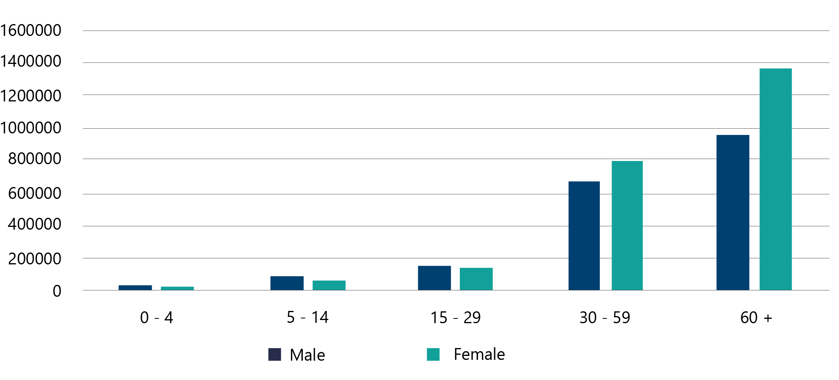
Source: Regososek 2022, as calculated by Bappenas 2023
Meanwhile, the National Socio-Economic Survey (Susenas) in March 2019 reported that the prevalence of persons with disabilities was higher, at 9% of the total population (Table 2), equating to approximately 23.3 million individuals (The National Team for the Acceleration of Poverty Reduction/TNP2K, 2019).
Table 2. Distribution of persons with disabilities based on Susenas March 2019
Age Group | Number of Population | Persons with disabilities (% of total Population) | Persons with disabilities (Number)
2 – 6 years | 23,595,255 | 2.5 | 585,892
7 – 18 years | 55,597,139 | 1.4 | 780,558
19 – 59 years | 152,911,587 | 7.3 | 11,195,246
60+ years | 25,649,285 | 41.9 | 10,739,821
Total | 257,753,266 | 9.0 | 23,301,517
Source: Susenas March 2019, as calculated by TNP2K 2019
Although the Long-Form Census 2020, Regsosek 2022, and Susenas 2019 adopted the Washington Group Questions on Disability, they showed different disability prevalence rates. This may be due to several factors, including the purposes of data collection, time frame, methods and number of participants (Table 3). Susenas 2019 had the smallest sample, allowing deeper questions related to the socio-economic situations of households in Indonesia. In contrast, Regsosek 2022 collected data from the entire population, but had limitations in capturing all socio-economic variables. Hence, these datasets are not directly comparable, but complement each other (Suárez & Cameron, 2022). Regardless of showing different numbers, both datasets recorded that older persons have by far the highest prevalence of disability among all age groups.
Table 3. The differences between Susenas 2019, Long-Form Census 2020, and Regsosek 2022
Aspects | Susenas 2019 | Long-Form Census 2020 | Regsosek 2022
Purpose | Monitoring and evaluating the socio-economic situation of households | Developing a benchmark of population indicators and evaluation of development programs. | Developing a single population dataset to portray the welfare population
Data collection time frame | March 2019 | May – June  2022 | October – November 2022
Data collection methods | Paper Assisted Personal Interviewing | 4 different methods, including PAPI, CAPI, CATI, and CAWI | Paper Assisted Personal Interviewing
Number of Participants | 320,000 households (0.46%) | 4,294,896 households (6.08%) | 78,318,709 households (100%)
- Disability question set | 8 questions about function difficulties adopted from the Washington Group Questions Short Set, consisting of seeing, hearing, walking/ climbing, holding objects, remembering, emotional regulation, communication, and self-care difficulties. | 9 questions about functional difficulties, adopted from the Washington Group Question Short Set. The questions are similar to Susenas 2019, with an additional question about learning difficulty. | 10 questions about functional difficulties, adopted from the Washington Group Question Short Set. The questions are similar to the Long-Form Census 2020, with an additional question about depression.
Source: BPS Kapuas Regency (2022) for Regsosek 2022, BPS (2023b) for Long-Form Census 2020, and BPS (2019) for Susenas 2019.
The Long-Form Census 2020 was disaggregated based on types of disabilities (Figure 3). In terms of moderate to severe disabilities, walking difficulties have the highest number, with 0.68% of the population (1.8 million people). However, when mild difficulties are considered, persons with sight difficulties represent the largest cohort, with 3.31% of the population (8.9 million people).
Figure 3. Distribution of persons with disabilities based on types of difficulty
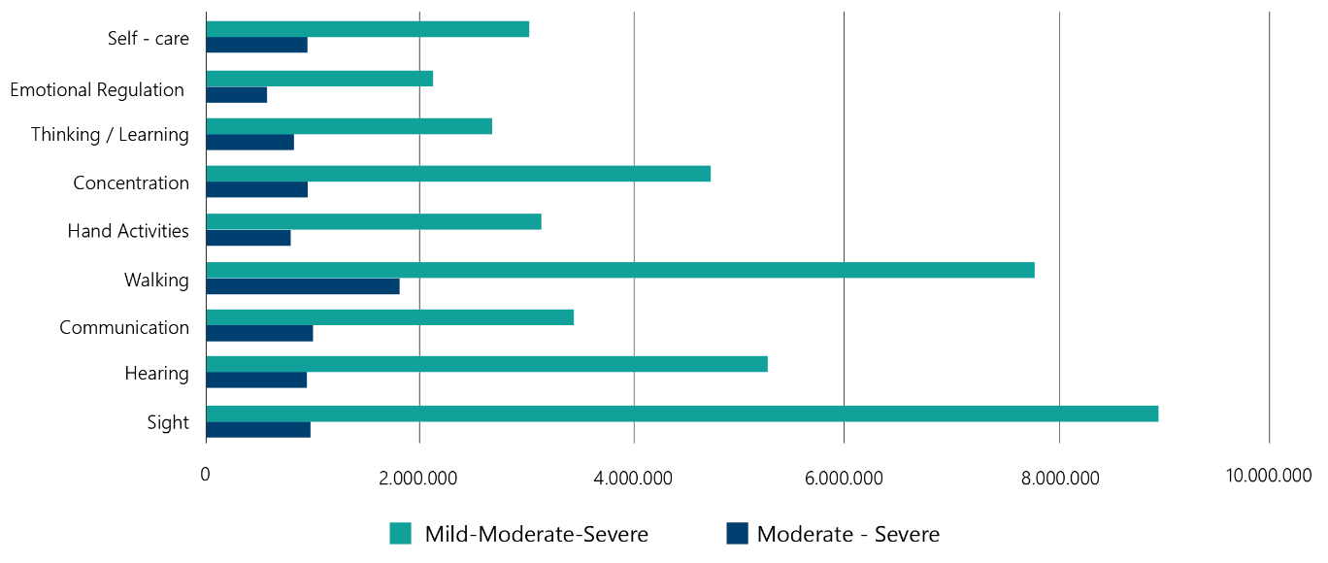
Source: Long-Form Census 2020 (BPS, 2024), as calculated by author 2025.
Experiences of disability influence not only the lives of individuals, but also those of their families. According to Regsosek 2022, 10.1 million households in Indonesia have one or more members with disabilities (OJK, 2024). This means that disability impacts individuals in 13% of households in Indonesia.

Persons with disabilities and extra cost
Persons with disabilities require extra costs to cover their needs to participate equitably in their communities. In Indonesia, these needs include (but are not limited to) assistive devices, human assistance, transportation, health and medical treatment, school and education support, and work support (Marlina et al., 2024). This range of needs impacts the spending of households with members with disabilities. Consequently, two households with the same income, but one with a person with a disability and one without, may have very different standards of living (Mitra et al., 2017; Mont et al. 2023).
A recent study (Marlina et al., 2024) reported that households with members with all levels of disabilities in Indonesia spend up to 20% more than their households without any members with disabilities (Figure 4). Furthermore, people with remembering/concentrating difficulties tend to spend more money than people with other functional difficulties.
Figure 4. Extra expenditure by households with various types of disability
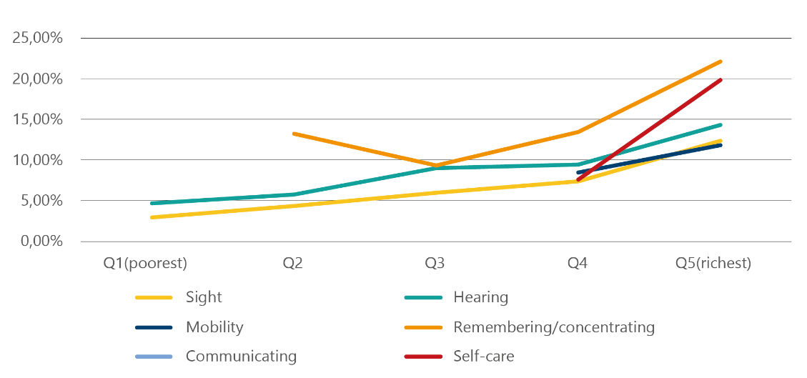
Source: Marlina et al., 2024
Lastly, Figure 4 indicates that wealthier households have higher relative expenditures related to disability. However, this does not necessarily mean that poor persons with disabilities need less; rather, they may not have the resources to buy what they need, or they may be living in areas where it is not available (Mont et al., 2022). After all this only represents what is currently being spent, not necessarily what is needed to allow for full participation.

Persons with disabilities and the poverty cycle
Disability status correlates with poverty across all age groups, yet is most apparent for people above 59 years old (TNP2K, 2019). Alabshar et al. (2024) examined data from Susenas 2020, reporting that persons with disabilities are more likely to be in extreme poverty than those without disabilities (see Table 4).
Table 4. The percentage of poverty level based on disability status and gender
Gender | Extreme Poverty Level (%) – Persons with disabilities | Extreme Poverty Level (%) – Persons without Disabilities
All | 8.18 | 5.49
Male | 8.34 | 5.37
Female | 8.05 | 5.61
Source: Susenas 2020 as counted by Alabshar et al. 2024
However, this poverty estimation is an underestimate of the actual living conditions persons with disabilities face because it does not account for their extra costs of living (Mont, 2023). According to Marlina et al. (2024), when disability costs are taken into account, the poverty rate among households with members with disabilities increases further (Figure 5). Among people with slight/moderate/severe disabilities, the poverty rate increases from around 13% to 20%. Meanwhile, the poverty rate of people with moderate/severe disabilities increases from 16% to 27%.
Figure 5. Adjusted poverty rate of households having members with disabilities
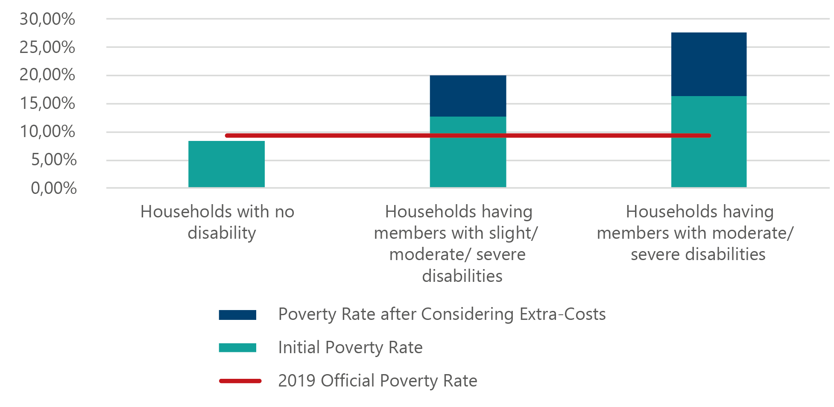
Source: Marlina et al. (2024) based on Susenas 2019
One option to address this would be to simply raise the poverty line for persons with disabilities based on the average extra expenditures. However, the great variance in expenditures depending on the nature of the disability rules out the effectiveness or efficiency of this approach (Mont et al. 2023, Mont 2023). Some people have much higher needs than others, and the nature of those needs can differ depending on the type of disability – for example, assistive technology, human support, additional medical care, rehabilitation, etc – which may be better targeted through service delivery, and may be so high as to make income-based targeting not very relevant. For example, in Figure 6 below from South Africa (a country with similar per-capita income as Indonesia) the level of disability resourcing needs is often greater than the entire household income of a great portion of the population.
Figure 6: Income Distribution in South Africa and Examples of Estimated Needs for Goods and Services by Type of Disability
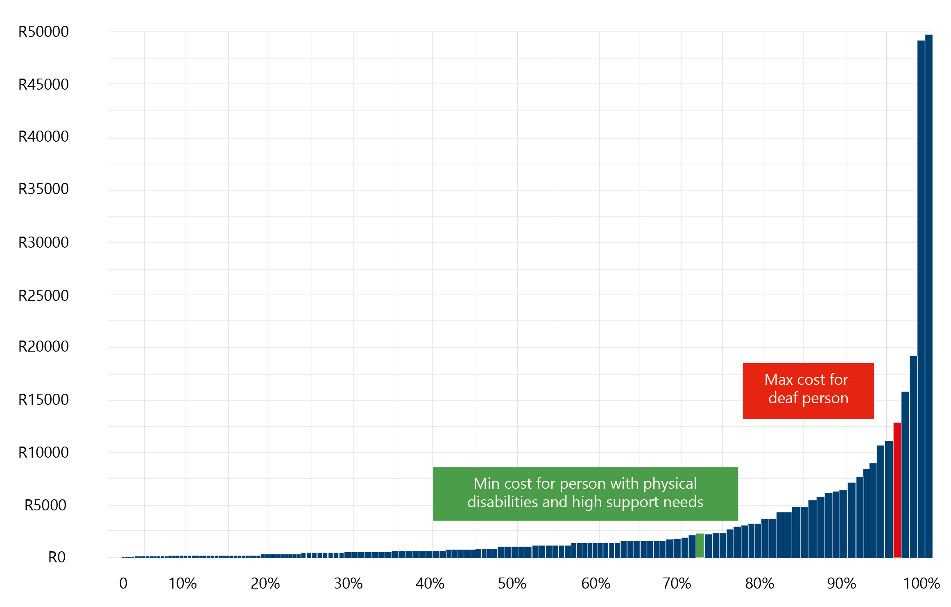
Source: Department of Social Development, Elements of the financial and economic costs of disability to households in South Africa. Results from a pilot study. (2015). DSD South Africa: Johannesburg.
Poverty is correlated with poorer health protection, education, and employment (Alabshar et al., 2024). Each component influences persons with disabilities to remain trapped in poverty across their life cycle. For instance, Susenas 2023 reported that 48.8% of persons with disabilities had health problems in a month when data was collected (TNP2K, 2024). This percentage was significantly higher than persons without disabilities, at only 24.6%. This means that persons with disabilities need to spend more money on health treatment than others, though they have similar incomes.
In terms of education, school participation for students with disabilities also requires extra support, such as accessible transportation, human assistance, and assistive tools (Marlina et al., 2024). Hence, failing to fulfil these needs can lead to lower school attendance. According to the Long-Form Census 2020 (BPS, 2024), students with disabilities in any age group experience lower attendance rates than non-disabled ones (see Table 5).
Table 5. Comparison of school attendance between people with and without disabilities
Age group and status | % of Students with Disabilities | % of Students without Disabilities
7-12 years old
Not attending | 18.95 | 4.76
Not completing primary school | 73.36 | 83.07
Completing primary | 7.69 | 12.18
Total | 100.00 | 100.00
13-15 years old
Not attending/ completing primary school | 31.74 | 9.26
Completing primary school | 50.26 | 64.07
Completing JHS | 18.00 | 26.67
Total | 100.00 | 100.00
16-18 years old
Not attending/ completing primary school | 23.85 | 3.29
Completing primary school | 15.19 | 10.76
Completing JHS | 43.17 | 60.55
Completing SHS | 17.78 | 25.40
Total | 100.00 | 100.00
19-23 years old
Not attending/ completing primary school | 23.89 | 2.80
Completing primary school | 12.64 | 9.38
Completing JHS | 16.01 | 19.21
Completing SHS | 44.34 | 64.66
Completing a higher degree | 3.11 | 3.95
Total | 100.00 | 100.00
Source: Long Form Census 2020, as calculated by BPS 2022
This same pattern also occurs in educational levels of persons with disabilities in the working age bracket (aged 15 years and above). Among working aged persons with disabilities 74.42% have only completed primary school or below. This percentage is significantly higher than those without disabilities at 36.83%. Moreover, only 4.13% of persons with disabilities complete higher degrees, compared to 10.23% of their non-disabled counterparts. Of course, some of the working age persons with disabilities may have acquired their disability post their schooling years. This means that some of this gap is not the result of exclusion from school, but from the fact that people with less education may be more susceptible to the onset of disability because of unsafe living and working conditions. Unfortunately, no data on age of onset of disability exists to explore these in more detail and parse out the various effects.
Table 6. Comparison of educational level between people with and without disabilities aged 15 years and above
Last completed education | Percentage of persons with disabilities | Percentage of persons without disabilities
Higher education | 4.13 | 10.23
Senior high school | 11.54 | 30.69
Junior high school | 9.91 | 22.25
Primary school | 39.30 | 28.10
Uncompleted primary school/ No Education | 35.12 | 8.73
Total | 100.00 | 100.00
Source: Long-Form Census 2020, as calculated by BPS 2022
This low education level contributes to limited work opportunities for persons with disabilities (BPS, 2023). The analysis of the National Labor Force Survey (Sakernas) 2020 indicated that the portion of persons with disabilities participating in the labour force is only 44.55%, far behind those without disabilities at 70.01% (Table 7). Those persons with disabilities who do join the labour force show several consistent patterns, including a better education background (at least completing primary school) and having less severe disability conditions than those who do not enter the labour force (Siregar et al., 2021). This finding strengthens the connection between work opportunity, educational attainment and disability level. Furthermore, Table 6 shows that employees with disabilities earn IDR 500,000 less and work 4 hours less than those without disabilities. Hence, with reduced income and increased costs, persons with disabilities face a greater risk of falling into poverty.
Table 7. The employment situation of persons with disabilities and persons without disabilities
Variables | Persons with disabilities | Persons without disabilities
Labor Force Participation Rate (%) | 44.55% | 70.01%
Wage (IDR) | 1,375,428 | 1,860,736
Having Additional Occupation (%) | 13.35 | 11.72
Employed in Formal Sector (%) | 30.49 | 48.27
Hours Worked Main Occupation (hours) | 29.85 | 33.98
Hours Worked All Occupation (hours) | 31.41 | 35.43
Source: Sakernas 2020, as calculated by Siregar et al. (2021)
In addition to employment rates, there is the issue of the type of employment. Persons with disabilities are more likely to work in the informal sector, casual work or self-employment (ILO 2017). This effect is stronger for women (Caron 2021). While persons with disability are more often in more vulnerable employment, the wage gap is more complicated. Those with functional difficulties but no medical diagnosis earn about 22% less (Caron 2021) than persons without disabilities, but those with medically diagnosed conditions earn about the same as persons without disabilities – but of course that is conditional on being employed.
Interestingly, the barriers to formal employment seem to lead to a higher rate of entrepreneurship among persons with disabilities than persons without disabilities in Indonesia. However, this occurs in the informal sector, with lower income gains (Adanisa 2019).
Partly due to less employment and less remunerative employment, poverty is even more prevalent when households have heads with disabilities. The Long-Form Census 2020 (BPS, 2024) counted that the percentage of households with disabled heads is 10.18% of total households. From this portion, the number of women-headed households is three times more than the number of men-headed households (BPS, 2024). These households headed by persons with disabilities are 1.3% more likely to be in poverty and have a 2.6% deeper poverty gap index than other households (Bella & Dartanto, 2018).

Social Protection Programs for Persons with Disabilities
Based on BPS (2023a), the percentage of social protection investment in gross domestic product (GDP) is 2.10%. This number has increased by 0.37% over the 5 years. Social protection programs in Indonesia are classified into non-contributory and contributory schemes (TNP2K, 2018). Non-contributory schemes are means tested and provide several cash transfer programs for poor families (PKH, PIP), food vouchers for poor families (BPNT), health insurance for poor families (JKN-PBI), and training grants for unemployed and informal workers (Prakerja). Meanwhile, contributory schemes provide health insurance, employment protection, and employment pension to people with ties to the formal labour market. Though no disability-specific social protection programs exist, some schemes include persons with disabilities as their beneficiaries. The contribution of these programs across the life cycle of persons with disabilities can be seen in Figure 7.
Besides these programs, the Government of Indonesia (GoI) provided Social Rehabilitation Assistance (Asistensi Rehabilitasi Sosial/ ATENSI) for persons with disabilities living below the poverty line (Ministry of Social Affairs, 2021a). ATENSI offers a wide range of support for persons with disabilities across the life cycle, along with support for their families. This support includes:
- Good and service support to fulfil basic needs, including food, clothing, safe habitation, health services, and educational access
- Support for families having children with disabilities, in the form of emotional support and life skill development
- Therapy supports
- Vocational and entrepreneurship training for persons with disabilities of working age
- Social assistance for families
- Accessibility provision, including support for assistive tools and advocacy for accessibility facility developments.
However, no evidence has been found related to the number of persons with disabilities receiving these ATENSI benefits.
Figure 7. Social protection programs across the life cycle of persons with disabilities
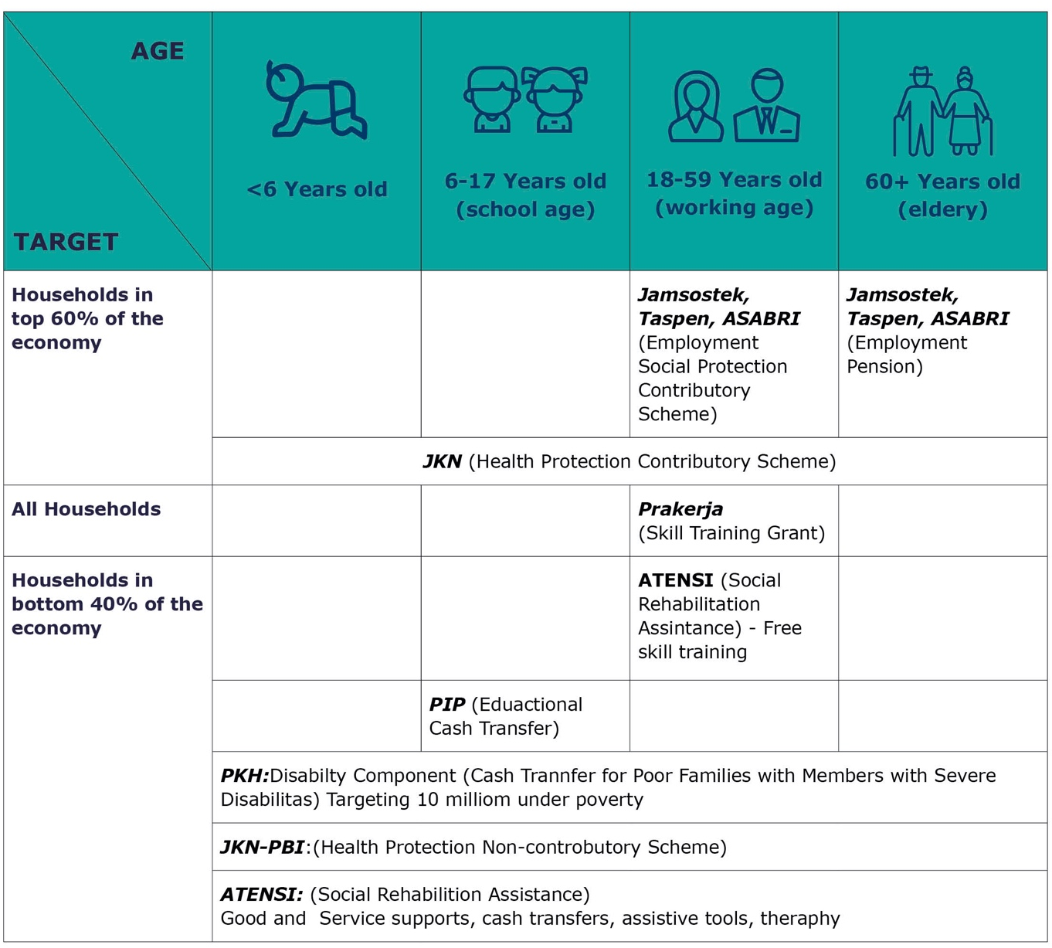
All poverty alleviation programs identify recipients based on Data Terpadu Kesejahteraan Social/ DTKS (Integrated Social Welfare Data). This dataset covers households living in poverty and displaced individuals. The identification and verification of eligible households and individuals is organised by sub-district governments, which then submit the identities to the national government under the Ministry of Social Affairs. In 2021, Bappenas recorded 1,171,544 individuals with disabilities registered in DTKS (Figure 8).
Figure 8. The distribution of persons with disabilities registered in DTKS
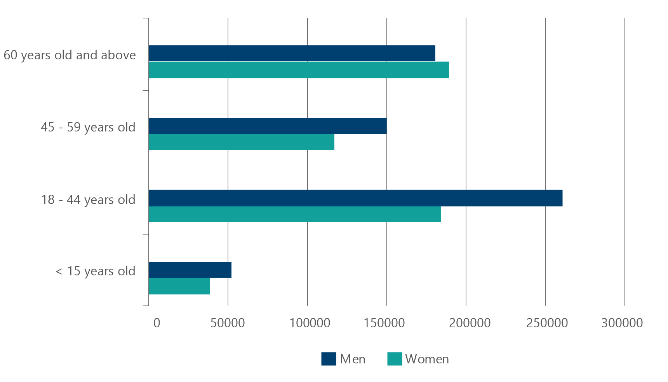
Source: Bappenas 2020, cited by INKLUSI (2023)
However, being registered in DTKS does not guarantee that individuals receive social protection programs. This can happen because each program has different requirements and mechanisms, as well as limited quotas and budgets (Ramadhan, 2024). In terms of non-disability-specific programs, the percentage of persons with disabilities receiving benefits is far below the percentage of their counterparts without disabilities (see Table 8). This indicates that non-specific disability programs are less equitable in providing social protection for persons with disabilities. Table 8 also reflects a lack of support for older persons with disabilities, the most at-risk group to poverty. The only cash transfer reaching older persons with disabilities is PKH, which only benefits 0.49% of persons with disabilities.
Table 8. The comparison between recipients with disabilities and without disabilities in non-disability-specific social protection programs
Program | Description | Age Target | Year of Data | Recipients with disabilities (number) | Recipients with disabilities (% per disability population) | Recipients without disabilities (number) | Recipients without disabilities (% per non-disability population)
PKH | Cash transfer for 10 million poor families | All age | 2018 | 111,078 | 0.48 | 9,888,922 | 4.22
PKH | Cash transfer for 10 million poor families | All age | 2020 | 113,111 | 0.49 | 9,886,889 | 4.22
PIP | Educational cash transfer program for students from poor families | 7- 21 years old | 2019 | 91,806 | 11.76 | 17,608,937 | 32.12
Prakerja | Training grants for unemployed and informal workers | 18 – 59 years old | 2020-2024 | 569,629 | 5.09 | 18,418,012 | 13.00
JKN-PBI | Non-contributory health protection for poor families | All age | 2019 | 8,874,338 enrolled as members | 38.08 | 78,254,535 enrolled as members | 33.38
JKN-PBI | Non-contributory health protection for poor families | All age | 2023 | 12,717,898 enrolled as members | 54.58 | 104,995,465 enrolled as members | 44.78
JKN Non-PBI and private protection programs | Contributory health protection | All age | 2019 | 6,804,043 enrolled as members | 29.20 | 89,510,084 enrolled as members | 38.18
JKN Non-PBI and private protection programs | Contributory health protection | All age | 2023 | 4,921,350 enrolled as members | 21.12 | 68,264,378 enrolled as members | 29.12
Source: Coordinating Ministry of Economic Affairs (2024) for Prakerja; OJK (2024) for JKN 2023 and JKN-PBI 2023; TNP2K (2019) for PIP, JKN 2019, and JKN-PBI 2019; TNP2K (2021) for PKH 2018 and 2020, as calculated by authors 2025

Cash Transfer for People with Severe Disabilities (2006 – 2020)
From 2006 to 2020, GoI had a cash transfer program for persons with severe disabilities called Social Assistance for People with Severe Disabilities/ Asistensi Sosial Penyandang Disabilitias Berat/ ASPDB (2006-2018), which then changed into Social Assistance for People with Disabilities/ Asistensi Sosial Penyandang Disabilitias/ ASPD (2019-2020). In this program, ‘persons with severe disabilities’ refers to those who are unable to independently perform daily activities and require lifetime financial support (TNP2K, 2018). Overall, the number of recipients increased significantly from 2006 to 2018, from only 3,750 to 22,500 individuals (Table 9). However, the number of recipients remained low compared to the overall population of persons with disabilities, with only 0.1%. After 2020, this program then merged with PKH.
Table 9. The details of ASPDB and ASPD
Aspects | ASPDB (2006 – 2018) | ASPD (2019 – 2020)
- Beneficiaries | - Persons with disabilities aged 2 – 55 years old  - Unable to independently perform daily activities  - Require a lifetime financial support | - Persons with disabilities aged 6 months to 60 years old  - Unable to independently perform daily activities  - Require a lifetime financial support
- The number of benefits | - IDR 3,600,000/ year, received in 3 terms | - 2019: IDR 3,600,000/ year, received in 3 terms  - 2020: IDR 2,000,000/ year received in one term
- Number of beneficiaries | - 2006: 3,750 persons with disabilities  - 2018: 22,500 persons with disabilities | - 2019: 22,500 persons with disabilities  - 2020: 23,700 persons with disabilities
- Distribution Mechanism | - 2006 – 2015: Cash distribution  - 2016 – 2018: Cashless distribution | - Cashless distribution
- Complaint mechanism | - Through the Society Complaint Unit under the Ministry of Social Affairs | - Through the Social Department in each region.
Source: TNP2K, 2021

PKH/ Cash Transfer for Poor Families
PKH is a cash transfer program targeting the bottom 40% of households with the lowest income. Households will receive benefits if they have one or more members with the criteria shown in Table 10.
Table 10. PKH components and the criteria of beneficiaries
PKH Component | Criteria
Health | - A family has a pregnant or breastfeeding mother  - A family has children aged below 6 years old
Education | - A family with one or two members aged 6 to 21 years old
Social Welfare | - A family has a member aged 60 years old and above (elderly)  - A family has a member with severe disability
Source: Ministry of Social Affairs, 2021b
The incorporation of ASPD into PKH led to a bigger budget, allowing more recipients with disabilities (Zakiah et al., 2020). However, the program regulated that the beneficiaries of the disability component are not allowed to exceed 150,000 people (TNP2K, 2021). No evidence was found in the literature on how the program selected beneficiaries. In addition, each household can only register one person with disability (Zakiah et al., 2020). Consequently, the number of disabled beneficiaries is still low compared to the total disabled population (0.49%) and all program beneficiaries (1.13%).
Incorporating the disability component into PKH had both positive and negative impacts. On one side, PKH requires family recipients to serve, support, and ensure yearly medical check-ups for their members with disabilities (Ministry of Social Affairs, 2021b). Positively, this motivates families to maintain the quality of life of their members with severe disabilities. However, on the other side, the family approach used in PKH is not suitable for reaching all persons with disabilities in poverty (Zakiah et al., 2020). There are possibilities of persons with disabilities living alone, or lacking support from families, leading to their ineligibility to receive programs. Furthermore, as the benefits are received by families, there is a possibility that these benefits are not optimally used for disability needs. However, further research is needed to understand these dynamics.

Educational Support
GoI provides several programs targeting school-age and working-age individuals: PIP (Educational Cash Transfers) for school-age individuals, and Prakerja and ATENSI Skill Training for working-age individuals. PIP and Prakerja target both persons with and without disabilities, while ATENSI specifically targets those with disabilities.
PIP is a cash transfer program to support educational needs, such as books, transportation, and e-learning modules, benefiting students from households living below the poverty line. The range of support varies from IDR 450,000 to 1,000,000 depending on school levels. Although students with disabilities may incur extra costs, the percentage of recipients with disabilities is only 11.76%, far below the percentage of those without disabilities at 32.12% (see Table 8). This shows that students without disabilities are still disproportionately benefiting from such programs.
Unemployed and informal workers aged 18 years and above can access Prakerja, a grant for paying for skill training to improve their employability. With the grant, the recipients can independently choose the classes offered by training providers partnering with GoI. However, during 2020-2023, Prakerja benefited only 4.7% of persons with disabilities in Indonesia (Table 8). Similar to PIP, this number is low compared to their non-disabled counterparts, at 13% of the population. The low participation of persons with disabilities was influenced by low awareness of the program’s existence and lack of access (Siregar et al., 2021). As this program is accessed online, it cannot reach the majority of persons with disabilities who lack digital access.
Working-age individuals can also receive skill training through ATENSI. The program covers vocational training and entrepreneurship assistance. In 2020, Integrated Social Welfare Data (DTKS) recorded 750,495 individuals with disabilities eligible to receive programs (Ministry of Social Affairs, 2021a). However, more data is needed to identify the real number of persons with disabilities benefiting from this program.

Health Protection Programs
Health protection operates through a contributory scheme (National Health Insurance/ Jaminan Kesehatan Nasional/ JKN) and a non-contributory scheme for the poor (Contribution Assistance Recipient-National Health Insurance/ Jaminan Kesehatan Nasional-Penerima Bantuan Iuran/ JKN-PBI) (TNP2K, 2018). JKN contributions are paid by individuals or employers, while JKN-PBI contributions are fully covered by the government budget.
According to Susenas 2023 (cited by OJK, 2024), a significant portion of persons with disabilities participate in health protection programs, with 54.58% for non-contributory programs and 21.12% for the contributory scheme (see Table 8). However, this number only reflects people registered as members, not the beneficiaries of health protection programs. Hence, further evidence is needed to identify the program coverage for persons with disabilities.
In 2024, TNP2K recorded that only 28% of persons with disabilities were unregistered in JKN (both PBI and non-PBI). Of these unregistered individuals, 64.33% do not seek treatment when sick (Figure 9). Moreover, 13.3% of poor persons with disabilities are recorded as not enrolled in JKN-PBI (TNP2K, 2024). This indicates that health protection programs have not optimally protected persons with disabilities.
Figure 9. Access to health care for persons with disabilities
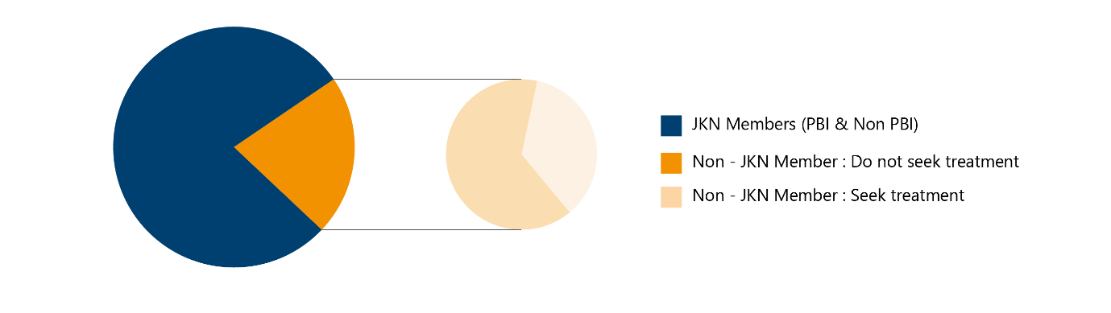
Source: Susenas 2023 as calculated by TNP2K, 2024
JKN members with disabilities reported several challenges in accessing JKN services, as below (TNP2K, 2024). However, this data cannot fully represent the real situation of beneficiaries with disabilities, as this was collected in a small sample. More data is needed to understand how JKN benefits (such as inpatient, medication, assistive devices, therapy) contribute to the lives of persons with disabilities.
Table 11. Challenges of members with disabilities in accessing JKN benefits
Type of service | JKN Services | Challenges
General | Health Facilities | Limited accessible health facilities, especially in Puskesmas (Community Health Centre) and clinics.
- General | - Health Workers | - Limited awareness and knowledge of health workers in handling patients with disabilities.
- Disability-specific | - Medication | - Specific disability medication is inaccessible, especially for mental disabilities and cerebral palsy conditions.
- Disability-specific | - Assistive Devices | - JKN Benefit Packages only cover 7 types of assistive devices, far fewer than WHO recommended (50 types). Moreover, these assistive devices do not specifically target persons with disabilities, yet general medical conditions (such as glasses, neck collar, dental prostheses). Hence, many persons with disabilities cannot access the assistive devices specific to their needs.  - The maximum rate of assistive devices covered by JKN is still below the price of assistive devices that meet the needs of persons with disabilities. Consequently, members with disabilities need to pay the excess price.  - The claim period for certain assistive devices is too long. For instance, a new leg prosthesis can be claimed after 5 years. This period is too long for children who are in the developmental stage.  - Limited skilled health workers in identifying the appropriate assistive devices.

Employment Support
GoI provides several contributory employment social protection programs, including Taspen, ASABRI, and Jamsostek. These programs support disability and work injury benefits, as well as pensions (TNP2K, 2020). Taspen and ASABRI specifically provide contributory services for civil servants, military, and police, while Jamsostek supports general employers (Table 12). However, as contributory schemes, these programs are only available for those who have been registered by their employers, commonly in formal sectors, or those who are self-enrolled and pay regular contributions. This provision applies to everyone, including persons with disabilities.
Table 12. Mechanism of Taspen, ASABRI, and Jamsostek
Program | Description | Mechanism
Taspen | Disability and pension benefits for civil servants | Automatically arranged by GoI
ASABRI | Disability and pension benefits for military and police | Automatically arranged by GoI
Jamsostek | Disability and pension benefits for self-employed and employees outside civil servants, military, and policy | There are two different mechanisms:  - Self-registration for self-employed individuals, the contribution will be paid independently  - Employer registration for employees, the contribution is shared between employees and employers
Source: TNP2K 2020 for Taspen and ASABRI, BPJS Ketenagakerjaan 2021 for Jamsostek
Nonetheless, around 48.49% of persons with disabilities work in primary sectors, such as agriculture, mining, fishing, and forestry (Table 13), associated with unskilled labour with lower wages, low value addition, and limited employment benefits. On the other hand, 38.36% of persons with disabilities work in tertiary sectors, such as trade, education, healthcare and tourism, which are typically related to specialized workers and secure employment protection. The lower level of tertiary sector employment among persons with disabilities suggests they are less likely to access employment benefits, contributing to limited employment protection and retirement pension. However, more evidence is needed to understand the coverage of these programs for persons with disabilities.
Table 13. Employment sectors of persons with disabilities and without disabilities
Sectors | Percentage of persons with disabilities | Percentage of persons without disabilities
Primary Sectors | 48.49% | 29.69%
Secondary Sectors | 13.13% | 20.32%
Tertiary Sectors | 38.36% | 50.00%
Source: Sakernas 2020, as calculated by Siregar et al. 2021

Experiences of persons with disabilities with social protection in Indonesia
Understanding the experiences and perspectives of persons with disabilities themselves is essential to inform the design of inclusive policies and programs. Persons with disabilities have the best understanding of the problems they face and have critical insights that can inform solutions to these. Crucially, the insights of persons with disabilities can often complement other data sources by explaining the nature and causes of gaps or inequalities in access to services – factors which are rarely explained by statistical or administrative data alone.
This section presents a summary of findings from three focus group discussions held with representatives of Indonesian organisations of persons with disabilities (OPDs) in March 2025. These discussions aimed to better understand the barriers and other issues that persons with disabilities in Indonesia face related to finding out about social protection entitlements, applying for benefits, having their eligibility for these benefits determined, and, if eligible, accessing and using their entitlements. Details of the FGD process are provided in Annex 2.
Within the limited scope of this study, only three focus group discussions were held, with the aim of highlighting potential issues and knowledge gaps to guide future evidence collection. A total of 28 persons from 21 OPDs participated in the FGDs. A diverse range of OPDs were selected, representing diverse groups of persons with disabilities from different parts of Indonesia. By engaging OPD representatives, the discussions were able to uncover issues experienced personally by the participants, as well as by the communities they represent. The findings from these discussions provide critical and powerful insights into the context of social protection for persons with disabilities in Indonesia. However, they represent only a partial snapshot and point to the need for further research with persons with disabilities and other stakeholders to inform specific system reforms.

Overall experience of persons with disabilities and social protection
Participants reported accessing various different of social protection programs, including JKN (the national health insurance program), JKN-PBI (the government-subsidized national health insurance program), 3-kg energy subsidy, medicine for persons with psychosocial disabilities, subsidy for UMKM (livelihood/ small enterprise), Permakanan (nutrition program), PKH cash transfer, Sembako (collection of staple food) during COVID response, ATENSI, and housing.
Most of the participants were aware of these aforementioned programs. However, many of them were only familiar with and had only accessed JKN and JKN-PBI, with very few of them accessing cash programs.
Several participants reported a perception of social protection as ‘bantuan’ (aid, in English), rather than as a human right or civic entitlement. Overall, knowledge and awareness of rights to social protection for persons with disabilities remain low.
Persons with disabilities who live in the city are more likely to report accessing social protection, compared to those who live in remote areas. For example, one participant living in Jakarta who has a psychosocial disability was able to access both disability-related medicine and at the same time benefits from the cash programs, Sembako and JKN-PBI. By contrast, participants who live in Sulawesi and remote areas in Ambon only reported accessing JKN-PBI.
“I might be lucky because I live in Jakarta, I can access different social protection. As a person with psychosocial disability, I have medicine covered, I receive cash, I received Sembako during COVID response.” (FGD participant, 10 March 2025)
Participants also reported that persons with disabilities from specific ethnic or minority groups and women with disabilities are more likely to be excluded from access to information, education, and economic empowerment.
“I want to highlight about our experience as women, have disability and from minority. We have so much barriers to access, many of us are illiterate because it’s hard to go to school, no access to information.” (FGD participant, 11 March 2025)
In addition, participants reported that families who have more than one member with disabilities experience more disadvantage, along with additional disability related costs.
Despite these gaps, participants reported some promising examples of social protection schemes and implementation in specific regions. For example:
- In Jakarta, public housing services target persons with disabilities and there is an educational fund for children of parents with disabilities.
- In West Java and the Special Region of Yogyakarta, collaboration between an OPD and a community health centre is ensuring access to therapy for children with disabilities.
- In East Kalimantan, a Social Assistance Plan covers 8,000 persons with disabilities, as the result of collaboration between an OPD and the Office of Social Affairs at provincial level.
Across these examples, participants reported that participation of and collaboration with OPDs is crucial to ensure that social protection payments or programs benefit persons with disabilities.

Key issues reported by persons with disabilities
Participants reported experiencing the following issues with understanding, accessing and benefiting from social protection programs:
- Issues with awareness of programs:
- OPDs play a crucial role in advocating to the government, which has increased the number of OPD members accessing social protection schemes. However, this creates gaps for persons with disabilities who are not members of OPDs – noting that this group is more likely to include people with cognitive disabilities, psychosocial disabilities, Deaf people and other more marginalised groups.
- Lack of accessible and inclusive information about social protection that creates a barrier for persons with disabilities to become aware of how to access different types of social protection programs/payments.
- Lack of awareness, knowledge and skills of government and administrators of social protection programs/payments about disability.
- An issue of using household criteria to identify or target individuals with disabilities, especially with reference to stigma (i.e. where persons with disabilities are hidden by their family).
- Issues with application and eligibility determination processes:
- Participants reported being aware of several ineligible recipients who have successfully accessed programs, for example, persons who have higher social-economic status or have no disability. The causes of this were not known, but participants report this as a concern among OPDs.
- Several participants were aware of government plans relating replacing DTKS with DTSEN, but were unclear of how this will apply to persons with disabilities. They raised questions such as ‘Will my eligibility status be deactivated?’, ‘Will this create new barriers for persons with disabilities?’, ‘How is this different to DTKS?’, ‘Will DTSEN include disability-related costs?’
- Participants reported that despite persons with psychosocial disabilities being eligible for free or subsidised medicine, they often face inappropriate questions by administrators related to their eligibility. Participants suggested a low level of disability awareness among social protection personnel, particularly in relation to ‘invisible’ disabilities. (At the same time, this may also suggest a problematic focus on medicine as a default option for persons with disabilities, despite other options being available.)
- Participants report that DTKS, the existing system for determining eligibility for program benefits, creates many issues for persons with disabilities. For example: disability support needs are not considered as a parameter for determining eligibility; household-level data or information does not accurately reflect the barriers and needs of individuals with disabilities; and people who are known by or close to the administrators or village leaders are more likely to be included in the DTKS, with others left out.
  - Participants report cases of positive determinations of eligibility resulting from a person’s closeness to community leaders or village administrators, or from direct individual level advocacy by local OPDs. This suggests significant local discretion in how eligibility criteria are applied – which can be both good and bad depending on how this discretion is applied.
- Participants raised concerns about transparency in determination criteria relating to DTKS processes, querying gaps in who is included in and excluded from the database, and lack of clarity over eligibility criteria.
- The eligibility criteria of social protection programs are often not clear. Participants reported many persons with disabilities being instantly determined to be not eligible due to the status of their parents, relatives or spouse. For example, an individual with disability who lives with their parents in a wealthy household may be ineligible, despite being unemployed and having no income.
“I am a person with disability, my wife is a civil servant. This automatically deactivates and makes me ineligible for any social protection scheme.” (FGD participant, 11 March 2025)
- Participants also reported that benefits could be deactivated without any notice. This created confusion for persons with disabilities, as the grounds for deactivation were reportedly not understood by them.
- Participants reported that many persons with disabilities have applied but have never received the results of their assessment. While the FGD sample was too small to make this a general conclusion, it suggests an issue which needs further exploration.
- Issues with receiving benefits:
- Participants determined as eligible reported barriers to receiving benefits due to inaccessible processes, such as long queues, inaccessible platforms, inaccessible facilities, and a lack of personal assistance provided. Some persons with disabilities have required support from third parties to obtain their benefits, with the costs of this coming from their own resources and often prohibitive. For example, one person reported that they were required to attend the post office to access their payment. But they needed a personal assistant to do so, and the cost was prohibitive. So, they did not bother to collect the payment.
“Back in 2016 or 2017 I received cash, but I had to go to post office to receive that. I could not go because I have no personal assistance, or I have to pay a third party to take the money from the post office. It cost me more and bureaucracy. So, I decided not to access it.” (FGD participant, 10 March 2025)
- One participant reported a case were a person fraudulently accessed social protection payments intended for a person with disability.
- Issues with the quality/quantity of benefits:
- Some participants reported receiving different benefit amounts, even though they are in the same social protection scheme. The reasons for this were unclear, but suggest there may be a lack of transparency in benefit levels and/or limited understanding of the details of schemes among recipients.
- Participants reported that persons with disabilities are not aware of complaints mechanisms, including their right to raise a report or claim if they receive a level of benefits that is less than their entitlement. Some persons with disabilities fear that raising a complaint will result in their being disqualified from receiving future social protection benefits.
- Participants reported that some non-cash benefits were of low quality and/or did not add up to the value to which they were entitled. For example, a participant reported receiving livelihood start-up supplies that were of low quality and didn’t add up to the full value of their package. This suggests there may be issues with how non-cash programs are administered.

Suggestions made by focus group discussion participants
The following suggestions were raised by focus group participants (noting that these are provided as an indication of participants’ priorities, rather than representing the authors’ recommendations):
- Improve basic awareness of persons with disabilities and disability rights for community leaders and social protection administrators. This should involve persons with disabilities in the process and aim to improve accessibility and effective coverage of diverse persons with disabilities in various social protection programs for which they are eligible.
- Provide information in accessible formats about social protection programs and their eligibility criteria and processes.
- Strengthen and enforce administration of social protection programs for persons with disabilities in compliance with relevant laws and policies.
- Build a one-stop disability database which is used to assess eligibility of persons with disabilities across different social protection payments/programs. This could include information on disability status from national ID cards, or utilize information from disability card if already existing.
- Simplify bureaucracy to register for and access social protection payments/programs, and ensure accessibility for persons with disabilities.
- Consider extra costs of disability within eligibility determination criteria.


International Examples
This section provides some brief examples from five different countries on issues related to the delivery of social protection benefits to persons with disabilities, focusing mainly on the determination system and how benefits are related to means testing and ability to work.
Collectively, the examples have been selected to illustrate a diverse range of system features that are potentially relevant to Indonesia. Some illustrate challenges and the lessons learned from these; others illustrate innovations that can be drawn from. Three of the five countries are upper-middle-income countries with similar per-capita income levels to Indonesia. The Philippines has lower income levels than Indonesia, but is in the same region and is currently piloting some innovative and instructive reforms. France is included as an example of a high-income country with a robust – but expensive – system of inclusive social protection for persons with disabilities.


South Africa
South Africa is an example of a country with multiple social protection programs in a country with equivalent GDP per capita as Indonesia. As in Indonesia, there are challenges in how grants are awarded and how they are aligned with the principles of the Convention on the Rights of Persons with Disabilities (CRPD) and the Joint Statement on Social Protection – in particular how disability is assessed and how benefits are linked to a perceived inability to work.
The disability components of the South African social protection system consist of a Child Support Grant, and Old Age Grant, and a Disability Grant. Applying for the first two is quite simple, based solely on assets and income, but the disability-specific grant requires four visits to institutions including two medical assessments. The process begins with a referral letter from a medical professional followed by a medical assessment by the South African Social Security Administration (SASSA). It is a time-consuming and expensive process that can serve as a barrier to those with resource constraints or accessibility issues.
The medical officer determines whether the grant is temporary, permanent with a review, or permanent without a medical review (but still a means assessment). Once identified as having a significant impairment, an applicant is assessed by the Medical Officer according to social factors such as their level of functional independence, education, employment history, age, and geographical area. One study found that this complex process, combined with limited government resources, prevents many people who could potentially qualify from receiving benefits.
The main challenges of the South African system are as follows:
- The means test is difficult to administer and thus excludes many people. Advocates have suggested removing the means test because disability costs are so high – especially relative to the size of the grants – that means tests are not relevant.
- The disability grant is only awarded to those who are not working, which discourages work. A solution to this would be to offer two grants – a disability pension along with a program targeting extra costs
- Entry into the system is purely medical and does not take into account functional difficulties, especially in the context of the applicant’s social environment.
- Benefits are restricted to a one-size-fits-all cash benefit, and so do not account for the variety of disability costs.


France
France, a much higher income country, has a very different system. It has multiple disability programs. The two main ones for adults are the focus here. This dual program approach tries to have a simple mechanism for addressing poverty related to disability (as in South Africa and Indonesia) but then adds on a more comprehensive program designed to address support needs and to break the connection between disability support and perceived inability to work.
The Disabled Adult Allowance is a means-tested program that provides a minimum income to meet daily expenses. Adults are assessed based on functional limitations according to a disability severity rating scale administered by the Committee for the Rights and Self-dependency of Disabled Persons. People qualify if they have a rating of 80%, or a rating between 50% and 79% with ongoing reductions in employment. They may not draw other social protection pensions over a certain amount or have financial means over a prescribed limit. The only benefits are cash, and they are designed as an anti-poverty measure.
However, there is an additional program, known as the Disability Compensation Benefit (PCH in French). This benefit is designed to compensate for the loss of autonomy of persons with disabilities in their daily lives, including their social lives. Applicants qualify if they cannot do any of 20 activities in the PCH reference framework without help or have at least two serious difficulties in carrying out these 20 activities in a “standardized” environment.
If qualifying, applicants get a full disability assessment and can qualify for five types of aid:
- human assistance
- technical aids
- accommodation or vehicle adaptations, and additional transport costs
- specific or exceptional aid
- animal assistance
All forms of assistance can be granted for a maximum of 10 years, but recipients can request a new assessment at that point.
While receipt of benefits is not means tested, the amount of benefits is affected by the applicant’s financial resources. Under a given income level, the PCH covers 100% of the amounts provided for each type of aid. Above that limit, it covers 80% of the planned amount. The idea behind this approach is that subsidies for support are needed by people across the financial spectrum because they are quite high, but as there is a need to limit the expense of the program they are reduced for people at the upper end of the income distribution who are more capable of obtaining them.
The strengths of the system are they are not linked to inability to work, and they are tailored to address individual needs. People with different types of and degrees of disability require different goods and services for equal participation. As noted earlier in this report, a one-size-fits all approach is neither efficient nor effective. However, the drawback is that the assessment system is very resource intensive, and the monetary value of the benefits far exceeds what is typically provided for in middle-income countries.


Armenia
Armenia, as a middle-income country, falls between South Africa and France, and is a leader in revising their assessment system. They recently changed it from a medically-based one to one that is based on the International Classification of Functioning (ICF).
However, to enter the system a person must have a medical referral. This requirement is often motivated by a concern about preventing fraud. That is, the system requires a medical reason behind someone’s functional limitations, even if they are being assessed on their functional limitations. Of course, the need for a medical certificate does not circumvent fraud, as doctors can receive bribes, as has occurred in many post-Soviet countries. For that reason, Armenia does not allow the applicant to choose the doctor doing the initial medical assessment. Rather, that doctor and the assessment team are randomly assigned to them.
Moreover, the assessment is done by a multi-disciplinary team that enters all of their findings in a digitized system which standardizes approvals and referrals. While this system is able to take a more holistic, functional approach to determining support needs, it is more intensive in that it requires a team of trained professionals. That is easy to come by in Yerevan, the capital of Armenia, but more of a challenge in rural areas.
Disability assessment is determined by functional limitations, as measured by the ICF ‘D codes’. ‘B codes’ refer to body functions and structures, while D codes refer to activities. While B codes are collected as important information for service providers, the determination of disability depends solely on activities (after the initial medical determination needed to trigger an assessment).
D codes fall into the following domains: Learning and Applying Knowledge, General Tasks and Demands, Communication, Mobility, Self-care, Domestic Life, Interpersonal Actions and Relations, and Major Life Areas. The assessment tool asks multiple questions within each activity domain. If the applicant is significantly limited in any activity domain, the person is determined to have a disability.
Benefits are not tied to the ability to work, and are not limited to a single cash payment, but also include service delivery. The main challenge now in Armenia is staffing enough assessment centres and service providers outside the capital city.


Thailand
Thailand is an example of a country in the region that also has eliminated the connection between disability benefits and the ability to work. The purpose of their Disability Grant is to support persons with disabilities by providing financial assistance to help cover basic living costs and address the additional expenses associated with having a disability, such as medication, transportation, and potentially lost family income. They are not tied to work limitations but are intended for individuals who experience functional difficulties in daily life and social participation due to impairments and barriers.
Obtaining a disability grant requires three steps: a medical examination by a licensed doctor which is then used to register for a disability ID card. Then, to receive a disability grant, the applicant must register at a local administrative office. The card also provides access to other welfare benefits and government support.
Current legal and policy frameworks shifted from a medical to a social and rights-based approach starting in 2007. This also included a shift towards functional questions in national surveys for the identification of persons with disabilities. Still, receipt of benefits is tied to a medical assessment, which can at times be difficult for people to obtain. Moreover, doctors may not recognize some functional difficulties that can significantly limit participation but which – on a doctor-to-doctor level – are not deemed ‘serious’ enough (e.g., ADHD in children). At the same time, studies have shown that front-line officers regularly overrule doctors’ decisions and require a person with a disability to return for a re-evaluation. The lack of clear standards is thus somewhat problematic.
While the grant has the benefit of not being tied to the ability to work for adults, the level of cash benefits is considered quite low, and does not reflect the variety of financial costs incurred by persons with disabilities. In addition, in many parts of the country services are difficult to come by.


Philippines
Philippines, another country in the region, is actively pursuing ways of making their assessment systems more compliant with the CRPD. In the past, disability determination was based solely on a medical certificate, but that has changed. At present, obtaining a disability ID card if one has an “apparent disability” (e.g., totally blind, missing limbs, etc.) requires only a certificate of disability from either the local health office or the issuing office (Persons with Disability Affairs Office or Local Social Welfare and Development Office). For “non-apparent disabilities” (e.g., intellectual disability, psychosocial disability, deaf or hard of hearing, etc.), they must obtain a certificate of disability from specialists or by appropriate physicians who have competencies to assess non-apparent types of disabilities.
The immediate benefits of a disability ID card are a 20% discount and exemption on value-added tax on selected goods and services such as transportation, cultural places, leisure and amusement, some medical services, and funeral services, as well as a 5% discount on basic commodities such as rice, bread, sardines, sugar, etc. If the ID holder is also in the database of the Philippine Registry for Persons with Disabilities, that person is fully subsidized and does not have to pay to access the State-run PhilHealth insurance. However, studies show that the main beneficiaries of these discounts are people in higher income quintiles living in urban areas. People with lower incomes or in rural areas do not have the means or opportunities to take advantage of these discounts.
Batangas, Philippines, recently pilot tested a disability assessment mechanism – including the determination of support needs, with the aim of creating an accessible, affordable, reliable, comprehensive disability assessment mechanism in compliance with the CRPD. This project was implemented in cooperation with national and local government, health professional organizations and non-government organizations and created four age-based modules, of which two were tested (5-17 years old and adult modules). KoboCollect, a free platform, was used to digitize the assessment tools and generate automated reports. Based on the success of the pilot, the Government of Philippines is pursuing funding to test it more broadly in preparation for a nationwide roll out. The goal is to determine individual support needs in preparation of designing services to deliver them.


Discussion and Recommendations
To plan for future policy reforms to strengthen inclusive social protection for persons with disabilities in Indonesia there is a need to address key knowledge gaps identified in this report to move the Indonesian social protection system to be more in line with the inclusive social protection framework outlined in the Joint Statement (summarized in Section 1). Particularly with regard to social protection programs that are designed for persons with disabilities, it is important for Indonesia to move more towards a model of social protection that enables equal protection (for all persons with and without disabilities), rather than being perceived simply as an anti-poverty program.
The evidence reviewed in this study points to some ways for Indonesia to move further towards this model. Key findings from the desk review and focus group discussions, along with lessons from the international examples, are discussed below with reference to the inclusive social protection framework presented in Section 1. Recommendations are provided for addressing identified knowledge gaps, including discussion of how they relate to opportunities for short- and long-term policy reforms.

Breaking the link between “incapacity to work” and receipt of disability benefits:
An “incapacity to work” approach creates barriers and disincentives to employment, instead of providing persons with disabilities with the support they require to engage in employment. A shift is needed towards recognizing the capacities of all persons with disabilities and addressing the barriers they face in the labour market. The evidence reviewed in this study indicates that Indonesia has made some progress in the design of inclusive programs, as the PIP and Prakterja programs support education and training for employment and therefore do not completely associate disability with the inability to work.
Other countries, including those in this report, can provide examples of how this can be done. For example, Thailand’s Disability Grant provides financial assistance to help cover basic living costs and address the additional expenses associated with having a disability, and is not tied to work limitations.

Recommendation 1: Once overall reform directions are set, more detailed evidence and analysis will be required to identify specific gaps in the system that need to be addressed. A process of regulatory review or policy/program mapping could be considered, applying specific analytical criteria informed by the Joint Statement. For example, this process could identify specific links between “incapacity to work” and receipt of disability benefits throughout the system.

Move from institutionalized care to support for independent living in the community:
Many countries are moving from a system where resources are focused on caring for persons with disabilities in residential institutions, towards one that supports the fundamental rights of persons with disabilities to live independently in the community. The scope of this study did not include evidence on the extent and nature of institutionalized care arrangements for persons with disabilities in Indonesia. However, evidence from the desk review highlights that a large number of persons with disabilities in Indonesia are living under the disability-adjusted poverty line, are not purchasing essential disability and health supports, and are significantly underrepresented among recipients of social protection programs targeting the general population – all of which are potential drivers towards institutional care, which need to be explored further.
In order to plan and budget for support for independent living in the community, information is needed on the distribution and personal and household characteristics of persons with disabilities throughout the population of Indonesia. There are various differing estimates of disability prevalence in Indonesia, and the prevalence data reviewed in this study does not yet provide all of the information needed for planning and budgeting for adequate coverage.
For many low- and middle-income countries, the scale of resourcing required to ensure adequate social protection coverage for all persons raises concerns about the available fiscal space. However, there are several examples of such countries prioritising resources to improve outcomes for persons with disabilities, within fiscal constraints. Thailand, for example, has begun reforming structural elements of its social protection system in line with the Joint Statement, while recognizing that benefit levels and coverage will need to be increased gradually over time.
Recommendation 2: More evidence is needed on the distribution of types and degrees of disability throughout the population and the nature and extent of their support needs, and how this is associated with personal and household characteristics. This information is needed to understand the budgetary implications of policy reforms and determine system resourcing levels for adequate coverage.
Recommendation 3: Evidence is needed on the extent to which persons with disabilities continue to live in residential institutions in different parts of Indonesia, the resourcing of these institutions, the experiences of persons with disabilities within them, and the drivers towards institutional care at household, community and policy level. Such evidence can help to inform policy settings and social protection system designs that address some of the factors that drive people towards institutional care and ensure that benefit levels and types are sufficient to support independent living in the community. Such measures would complement efforts outside of the social protection system to end the institutionalization of persons with disabilities.

Moving beyond one-size-fits-all eligibility thresholds and benefit levels:
Persons with disabilities often face significant disability-related costs and therefore require more resources to achieve the same standard of living as persons without disabilities. Costs also vary significantly depending on the type and level of disability, personal and household characteristics and geographic context. In order to make social protection more inclusive for persons with disabilities, eligibility thresholds should consider disability-related costs and benefits should adequately cover these costs through cash and in-kind mechanisms.
Indonesia has undertaken some work around understanding the extra costs of disability, but unfortunately those studies were not available for this review. The evidence reviewed in this study indicates that Indonesia has not yet moved away from a one-size-fits-all approach. For example, in ATENSI, no adjustments are made for the extra costs associated with disability, so families effectively living below the poverty line – because of disability-related costs that they incur – are not eligible for benefits from ATENSI. And as those costs can be quite high, many persons with disabilities who are excluded from that program would likely qualify, if those costs were accounted for in the assessment.
As the extra costs associated with disability come in part from barriers in the environment, Indonesia needs better information on how those barriers can create those costs (e.g., lack of accessible transportation) so that they (and the associated government expenditures need to cover them) can be reduced. This will take coordination across ministries.
Recommendation 4: More evidence is needed on the goods and services needed by persons with different types and degrees of disability, and how they change over the life cycle. This is essential to inform a move away from a one-size-fits-all approach, towards designing a system based on people’s diverse functional difficulties and support needs.
Recommendation 5: More evidence is needed on the cost and availability of goods and services in different geographical contexts, and how models of delivery can be best suited to local contexts. This is needed to inform the design of benefit packages that are feasible and appropriately resourced in diverse contexts. For example, providing human support services in rural and urban areas may need to incorporate different approaches.

Mix of schemes across the life cycle. Cash, in-kind and access to services. Both mainstream and disability-specific:
Achieving social protection outcomes for persons with disabilities requires a mix of schemes, including cash and in-kind benefits, as well as mechanisms to facilitate linkages and support access to education, health, employment and economic empowerment services. A combination of mainstream and disability-targeted programs is needed. The dual program approach of France provides one example (albeit a resource-intensive one) of a system that aims to address poverty related to disability through a cash benefit, but then adds on a more comprehensive program designed to address complex support needs through a mix of in-kind benefits and services. In addition, improvements in infrastructure and other aspects of the environment can also reduce costs currently faced by persons with disabilities.
In Indonesia, though it is true that the ATENSI program moves beyond cash to offer goods and services, those are not based on a rigorous analysis of the required goods and services, and, more importantly, the program is targeted only towards people living in poverty. Focus group discussion participants have also suggested that the quality and quantity of in-kind benefits may be lacking in some instances.
Evidence reviewed in this study highlights significant gaps in access to mainstream social protection schemes for persons with disabilities: persons with disabilities access those schemes at lower rates than persons without disabilities, despite experiencing higher levels of poverty. Focus group discussions identified low awareness and understanding of various schemes, lack of accessible information and processes, accessibility barriers and undertrained personnel as factors potentially contributing to this gap (although the FGD sample was too small to support clear conclusions on this). Publicizing existing programs, training personnel and providing easy access to accessible information describing eligibility rules, application procedures and benefits, could provide a starting point for efforts to increase access.

Individualised disability assessment based on barriers and support requirements, as well as impairment and activity limitations:
As discussed above, moving beyond a one-size-fits-all approach requires a system that can identify and assess disability on an individualised basis. Crucially, building an inclusive social protection system requires moving away from entirely medical- or impairment-based systems, towards one that considers individuals’ barriers and support requirements, alongside their impairment and activity limitation.
Building a system that tailors benefits to individual needs, as in France, cannot be accomplished without an individualized assessment system that can determine support needs – and that includes the potential extra costs associated with working, to remove a barrier to work. While the French system may be too involved for Indonesia, the system being developed in the Philippines can offer a more workable example.
Recommendation 6: More information is needed – e.g. detailed system descriptions, analysis, case studies and/or direct knowledge exchange – on relevant international examples of systems for individualized disability assessment that are based on barriers and support requirements. This information can be used, with the involvement of persons with disabilities, to identify elements of such systems that could be adapted for Indonesia.

Accessibility and non-discrimination. Removal of physical, communication, information, institutional and attitudinal barriers. Equal access for diverse people in all locations:
Focus group discussions highlighted a range of barriers to understanding and accessing social protection programs and to receiving and using their benefits. Participants raised various issues of inaccessibility, lack of transparency and perceived discriminatory treatment. More information is needed on why persons with disabilities in Indonesia, as cited in this report, are less likely to access general social protection programs. Is this because of lack of awareness among eligible persons with disabilities? Or among administrative personnel? Or is it because of inaccessible application and disbursement procedures? Or interactions between program design, regulation, and implementation?
Robust and representative evidence is required on the barriers that prevent access to social protection, considering the diverse experiences of persons with disabilities in Indonesia depending on their type of disability, gender, geographic location, ethnicity, and other factors.
Recommendation 7: More evidence is needed on the barriers that diverse persons with disabilities experience at each stage of social protection programming, and their perspectives on opportunities to strengthen the system. This information is needed to strengthening overall system equity and coverage, and to identify the reforms and measures required to ensure key systemic features are in place – such as accessibility, non-discrimination and personal choice. Specific evidence could inform exploration of ‘one-stop shops’ that can potentially address issues of low awareness and barriers to access, by reducing travel and time needed to learn about and apply for multiple programs.

Personal autonomy, choice, privacy and control over benefits. Direct receipt by persons with disabilities. Recognition of legal capacity:
Social protection benefits, whether mainstream or disability-specific, should always be provided to persons with disabilities in a way that allows for their choice and control over the benefit. Benefits aimed at supporting persons with disabilities should be individual and directly received by the person with disabilities, and their legal capacity to register for and receive benefits should be recognized.
Evidence reviewed in this study did not support clear conclusions on the extent to which persons with disabilities in Indonesia maintain personal autonomy, choice, privacy and control over benefits. However, international experience suggests this presents an issue in most contexts, and evidence from the desk review and FGDs suggest this may be the case in Indonesia.
For example, the desk review considered the disability component of PKH, which requires family recipients to support their family members with disabilities. The program does not reach persons with disabilities who live alone or who lack support from their families and, as the benefits are received by families, there is a possibility that these benefits are not used for disability needs or according to the wishes of the person with disability.
Recommendation 8: More evidence is needed on the extent to which persons with disabilities in Indonesia maintain personal autonomy, choice, privacy and control over social protection benefits, including within individual households. This requires analysis of disbursement procedures, as well as qualitative research into the experiences of diverse persons with disabilities across various geographic and demographic contexts. Such research could be integrated with analysis of barriers (Recommendation 7).

Meaningful consultation with persons with disabilities in system design, implementation and monitoring:
The perspectives of persons with disabilities themselves are essential to understanding these diverse barriers and to shaping more effective and sustainable change and contributing to the realisation of the rights for persons with disabilities in Indonesia.
Focus group discussions held under this study, although limited in scope, have highlighted a range of potential issues in system design and implementation. These include low awareness of social protection programs and low understanding of eligibility criteria, uneven coverage of programs across geographical regions and among more disadvantaged households, gaps in knowledge and policy/procedural compliance among system personnel, accessibility barriers in various processes, issues with the quality and quantity of non-cash benefits, and others. While the FGD sample was too small to draw general conclusions from these insights, it highlights the value of hearing directly from persons with disabilities and involving them in designing, implementing and monitoring the system.
Meaningful consultation with persons with disabilities is in itself a feature of inclusive social protection system design, and can set the scene for ongoing partnership between system stakeholders and persons with disabilities. Qualitative information – for example, that collected through focus group discussions or individual interviews – can reveal the reality of the lives of persons with disabilities and their interaction with the social protection system. Without this input, it is difficult to understand and then address their concerns, and design a system that meets the needs of all population groups
Recommendation 9: Build consultative processes and methodologies that feature the meaningful involvement of diverse persons with disabilities in efforts to address the knowledge gaps identified above.

Annexes

Annex 1: References
Alabshar, N., Pujiwati, L. A., Munawaroh, T., & Fatoni, Z. (2024). Disability and extreme poverty in Indonesia: Analysis of national socio-economic survey data in 2020. Jurnal Kawistara, 14(1), 86-102. https://doi.org/10.22146/kawistara.83519
Badan Pusat Statistik [Central Bureau of Statistics] (BPS). (2019). Statistik Kesejahteraan Rakyat 2019 [Welfare Statistic 2019].
Badan Pusat Statistik [Central Bureau of Statistics] (BPS). (2023a). Analisis tematik kependudukan Indonesia: Fertilitas remaja, kematian maternal, kematian bayi, dan penyandang disabilitas [Thematic analysis of Indonesian demography: Adolescent fertility, maternal mortality, infant mortality, and persons with disabilities].
Badan Pusat Statistik [Central Bureau of Statistics] (BPS). (2023b). Hasil Long-Form Sensus Penduduk 2020 [The results of Long-Form Census 2020].
Badan Pusat Statistik [Central Bureau of Statistics] (BPS). (2024). Potret penyandang disabilitas di Indonesia, hasil Long Form Sensus Penduduk 2020 [The depiction of persons with disabilities in Indonesia, results of 2020 Long-Form Census].
Badan Pusat Statistik Kabupaten Kapuas [Kapuas Regency’s Central Bureau of Statistics] (BPS). (2022). Pendataan awal Registrasi Sosial Ekonomi (Regsosek) 2022 [Early data collection of Integrated Socio-Economic Registration System 2022]. https://kapuaskab.bps.go.id/id/news/2022/09/12/54/pendataan-awal-registrasi-sosial-ekonomi--regsosek--2022.html
Bella, A., & Dartanto, T. (2018). Persons with disabilities (PWD) and poverty in Indonesia. Malaysian Journal of Economic Studies, 55(2), 167-188. https://search.informit.org/doi/abs/10.3316/INFORMIT.014669853196790.
Badan Penyelenggara Jaminan Sosial (BPJS) Ketenagakerjaan [Employment Social Protection Agency]. (2021). Informasi kepesertaan [Membership information]. https://www.bpjsketenagakerjaan.go.id/
Cheechang, K , W Kotbungkair† , S Arunsangsuree , S Vichit, “Leaving No One Behind: Analyzing the Inclusiveness of the Disability Grant Scheme in Thailand,” Chapter 5 in Rossi, A and R Villanueva (eds.) Social Protection in East Asia and Pacific: From Evidence to Action, UNICEF https://www.unicef.org/eap/media/13701/file/Chapter%205_Inclusiveness%20of%20the%20Disability%20Grant%20in%20Thailand.pdf
UNDESA (2024), Disability and Development Report 2024: Accelerating the realization of the SDGs by, for and with persons with disabilities. https://social.desa.un.org/publications/un-flagship-report-on-disability-and-development-2024
Department of Social Development, Elements of the financial and economic costs of disability to households in South Africa. Results from a pilot study. (2015). DSD South Africa: Johannesburg. https://www.unicef.org/southafrica/reports/elements-financial-and-economic-costs-disability-households-south-africa
ILO (2019), Joint Statement: Towards Inclusive Social Protection Systems Supporting the Full and Effective Participation of Persons with Disabilities, https://www.social-protection.org/gimi/gess/Media.action?id=16753
Inklusi. (2023). Inklusi GEDSI intersectional situation analysis.
Kementerian Perencanaan Pembangunan Nasional/ Bappenas [Ministry of National Development Planning/ National Development Planning Agency]. (2023). Registrasi Sosial Ekonomi [Integrated Socio-Economic Registration System] (Regsosek). https://sepakat-demo.bappenas.go.id/regsosek-dashboard/
Kementerian Koordinator Bidang Perekonomian [Coordinating Ministry of Economic Affairs]. (2024). Siaran press: Berhasil berikan pelatihan inklusif untuk jutaan orang di 2023, program prakerja resmi lanjut di 2024 [Press release: Successfully providing inclusive training for millions in 2023, pre-employment program officially continues in 2024]. https://www.ekon.go.id/publikasi/detail/5645/berhasil-berikan-pelatihan-inklusif-untuk-jutaan-orang-di-2023-program-prakerja-resmi-lanjut-di-2024.
Kementerian Sosial [Ministry of Social Affairs]. (2021a). Pedoman operasional Asistensi Rehabilitasi Sosial penyandang disabilitas [Operational guidance of Social Rehabilitation Assistance (ATENSI) for persons with disabilities].
Kementerian Sosial [Ministry of Social Affairs]. (2021b). Pedoman pelaksanaan Program Keluarga Harapan (PKH) [The guiding book for Poor Families Cash Transfer Program].
Kenya Ministry of Labour and Social Protection (2024), Support Needs Assessment Report for Persons with Disabilities and their Primary Caregivers, https://www.knbs.or.ke/reports/support-needs-assessment-report-for-persons-with-disabilities-and-their-primary-caregivers/
Kidd, S., L Wapling, D Bailey-Athios, A Tran,(2018) “Social Protection and Disability in South Africa”, Development Pathways Working Paper https://www.developmentpathways.co.uk/wp-content/uploads/2018/07/Social-Protection-and-Disability-in-South-Africa.pdf
Marlina, I., Wibowo, G., Bastias, D. D., Sijapati Basnett, B., Prasetyo, D. D., & Nasiir, M. (2024). Counting the costs: Understanding the extra costs of living with disability in Indonesia to advance inclusive policies within the SDG framework. Frontiers in Rehabilitation Sciences, 5, 1236365.
Mitra, S., Palmer, M., Kim, H., Mont, D., & Groce, N. (2017). Extra costs of living with a disability: A review and agenda for research. Disability and Health Journal, 10(4), 475-484.
Mont, D. (2023). Estimating the extra disability expenditures for the design of inclusive social protection policies. Frontiers in Rehabilitation Sciences, 4, 1179213.
Mont, D., Banks, L. M., Carraro, L., Cote, A., Hanass-Hancock, J., Mitra, S., ... & Pinilla-Roncancio, M. (2023). Methods for estimating the impact of disability costs for designing inclusive policies. Disabilities, 3(4), 539-549.
Mont, D., Morris, Z., Nasiir, M., & Goodman, N. (2022). Estimating households’ expenditures on disability in Africa: The uses and limitations of the standard of living method. International Journal of Environmental Research and Public Health, 19(23), 16069. https://www.mdpi.com/1660-4601/19/23/16069
Otoritas Jasa Keuangan [Financial Service Authority] (OJK). (2024). Pedoman akses pelayanan keuangan untuk disabilitas berdaya [The guidance of financial access services for empowered disability].
Ramadhan (July 16, 2024). Terdaftar di DTKS, tapi tak menerima bansos [Registered in DTKS, but not receiving social assistance]. Portal ID. https://waktu.ai/id/terdaftar-di-dtks-tapi-tak-menerima-bansos-2024/
Rwanda National Council on Persons with Disabilities, Rwanda Disability Management Information System (presentation), https://www.internationaldisabilityalliance.org/sites/default/files/marcel-nkurayija-ncpd-rwanda-30-march.pdf
Siregar, A., Anky, K., & Moeis, R. (2021). Assessing Indonesia’s inclusive employment opportunities for people with disability. In LPEM-FEB UI Working Paper 063, August 2021. ISSN 2356-4008. https://www.lpem.org/repec/lpe/papers/WP202163.pdf
Suárez, D. C., & Cameron, L. (2022). 10 Disability in Indonesia: What can we learn from the available data? In Sickness and In Health: Diagnosing Indonesia, 172.
Tim Nasional Percepatan Penanggulangan Kemiskinan [The National Team for the Acceleration of Poverty Reduction] (TNP2K). (2018). The future of the social protection system in Indonesia: Social protection for all.
Tim Nasional Percepatan Penanggulangan Kemiskinan [The National Team for the Acceleration of Poverty Reduction] (TNP2K). (2019). Disability situation analysis: Challenges and barriers for people with disability in Indonesia
Tim Nasional Percepatan Penanggulangan Kemiskinan [The National Team for the Acceleration of Poverty Reduction] (TNP2K). (2020). Policy brief: Inclusive social protection for persons with disability in Indonesia.
Tim Nasional Percepatan Penanggulangan Kemiskinan [The National Team for the Acceleration of Poverty Reduction] (TNP2K). (2021). Kebijakan dan program bantuan sosial untuk penyandang disabilitas: Pembelajaran Internasional dan Indonesia [Social assistance policy and programs for persons with disabilities: Lesson learned from International and Indonesia].
Tim Nasional Percepatan Penanggulangan Kemiskinan [The National Team for the Acceleration of Poverty Reduction] (TNP2K). (2024). Ringkasan eksekutif hasil kajian kecukupan paket manfaat JKN bagi peserta penyandang disabilitas [Executive summary of the study results of the adequacy of JKN benefit packages for members with disabilities].
UNICEF (2022), Cost of Raising Children with Disabilities in the Philippines. https://www.unicef.org/philippines/media/5941/file/Full%20report%20-%20cost%20of%20raising%20children%20with%20disabilities%20in%20the%20Philippines.pdf
Zakiah, K., Lestari, V. P., & Putra, H. D. (2020). Akuntabilitas pelaksanaan program keluarga harapan (PKH): Komponen kesejahteraan sosial (lanjut usia dan disabilitas berat) di Indonesia [Accountability of PKH Implementation: social welfare component (elderly and severe disabilities) in Indonesia. Pusat Kajian Akuntabilitas Keuangan Negara, Badan Keahlian DPR RI [Research Center of National Financial Accountability, DPR RI Expert Department].

Annex 2: Focus group discussions
Participants:
In order to capture brief from different region of Indonesia, consultation divided into three sessions during 10 – 11 March 2025. In total these were attended by 28 participants from 21 OPDs from Jakarta, Java, Sumatera, Sulawesi, Kalimantan, NTT, Bali, and Ambon.
Sessions were:
- Session I attended by 13 participants: 7 Female and 5 Male
- Session II attended by 5 participants: 3 Female and 2 Male
- Session III attended by 10 participants: 6 Female and 4 Male
The following OPDs were represented across the sessions:
Jakarta and Java area:
- Audisi - Jakarta
- FIDAKAMA – Disability Inclusion Forum District of Magelang
- HWDI – Indonesia Women with Disabilities Association
- KPSI – Indonesia Schizophrenia Community Care
- PPDI – Indonesia People with Disability Association – District of Cianjur West Java
- PELITA – Association of Indonesia Deafblind – Jakarta
- PERPENCA Jember – East Java
- PINILIH SEDAYU – Special Region of Yogyakarta
- PJS – Indonesian Mental Health Association – Jakarta
Sumatera, Sulawesi, Kalimantan:
- AIF – North Sulawesi
- Gema Difabel – South Sulawesi
- HWDI – South Sulawesi
- IPDP – Ikatan Persaudaraan Disabilitas Pidie
- PPDI East Kalimantan
- PERTUNI – Indonesian Blind Association province of West Sulawesi
Bali, Maluku, NTT:
- HWDI Bali
- HWDI NTT
- GARAMIN NTT
- PERMATA NTT
- PERTUNI Maluku
- PPUAD Maluku
The existing OPD social protection advocacy WhatsApp network was used to invite potential participants. In addition, invitations were sent via staff from CBM Global Indonesia to collaborating members of their OPD Capacity Strengthening program. It was open for persons with any type of disabilities; there was no specific question to the type of disability either in registration and participation list.
Discussion Questions:
Questions for people who have accessed social protection payments/programs (in the past or currently):
- What social protection programs or benefits are you accessing?
- How did you learn about the program?
- Were there any challenges in applying?
  - If so, how did you overcome them?
- What do you think of the criteria that are used to determine if you are eligible? And the process that is followed?
  - Are they reasonable and appropriate?
  - Was the process respectful or difficult?
  - How would you change them to work better?
- What do you use the benefits for?
  - Are the benefits sufficient for you?
  - Do you use them for your own personal purposes or for the household's purposes?
  - Do you have control over how your benefits are used?
- If you could change anything about the program you accessed, what would it be?
Questions for people who have not accessed social protection payments/programs:
- Have you applied for social protection payments/benefits?
  - If so, which payments/benefits?
  - If not, why not?
- Were there any challenges in applying?
  - If so, how did you try to address them?
- If you made it to the process to determine your eligibility, what did you think of it?
  - Was it reasonable and appropriate?
  - Was the process respectful or difficult?
  - How would you change it to work better?
- If you did apply, why do you think you were denied?
- If you had been successful and had received benefits, how would you have used them?

Annex 3: Selected annotated bibliography
Note: The selected annotated bibliography below provides a list of recommended sources of evidence relating to inclusive social protection for persons with disabilities in Indonesia. Select international sources are also included. The list does not include global commitments and guidance sources.
Alabshar, N., Pujiwati, L. A., Munawaroh, T., & Fatoni, Z. (2024). Disability and extreme poverty in Indonesia: Analysis of national socio-economic survey data in 2020. Jurnal Kawistara, 14(1), 86-102. https://doi.org/10.22146/kawistara.83519.
This article investigates the effect of disability and other control variables on extreme poverty. The control variable included residence area, age, sex, education, number of household members, marital status, and employment sectors. It used logistic regression on data derived from the Susenas 2020. The result is expected to provide recommendations for stakeholders in developing inclusive policies for living with disabilities.
Badan Pusat Statistik [Central Bureau of Statistics] (BPS). (2019). Statistik Kesejahteraan Rakyat 2019 [Welfare Statistic 2019].
This report provides data and analysis based on Susenas (National Socio-Economic Survey) 2019. The report includes information related to population, education, health, fertility, housing, information and communication technology, criminality, and social protection. The data is presented at national and provincial levels, allowing regional comparison. This report aims to support policy-makers, researchers, and other stakeholders by providing reliable socio-economic data.
Badan Pusat Statistik [Central Bureau of Statistics] (BPS). (2023a). Analisis tematik kependudukan Indonesia: Fertilitas remaja, kematian maternal, kematian bayi, dan penyandang disabilitas [Thematic analysis of Indonesian demography: Adolescent fertility, maternal mortality, infant mortality, and persons with disabilities].
This publication analyses thematic data from the Long-Form Census 2020, along with supporting studies and literature. It aims to provide information for stakeholders and policy makers in developing programs for human development. This publication covers four main themes, including adolescent fertility, maternal mortality, infant mortality, and the situation of persons with disabilities. However, the data in this publication is only presented in percentages, not in real numbers. Hence, more calculations are needed for better analysis.
Badan Pusat Statistik [Central Bureau of Statistics] (BPS). (2023b). Hasil Long-Form Sensus Penduduk 2020 [The results of Long-Form Census 2020].
This report presents the results of the Long-Form Census 2020, which was conducted in 2022. The report covers several indicators, including fertility, mortality, disability, education, and housing. This data is expected to provide indicators for the evaluation and monitoring process of SDGs (Sustainable Development Goals) and RPJMN (Medium-Term National Development Plan) outcomes.
Badan Pusat Statistik [Central Bureau of Statistics] (BPS). (2024). Potret penyandang disabilitas di Indonesia, hasil Long Form Sensus Penduduk 2020 [The depiction of persons with disabilities in Indonesia, results of 2020 Long-Form Census].
This publication provides a comprehensive discussion on disability data from the Long-Form Census 2020. This discussion aims to help stakeholders understand the situation of persons with disabilities and guide the development of inclusive policies. It portrays distribution data based on gender, age, households, education, and employment. Furthermore, the report also discusses several trends of the population with disabilities, including mortality, fertility, population growth, urbanization, and internal migration. However, similar to BPS Thematic Analysis, this report only provides the data in percentages, not in actual numbers. Hence, the manual calculation is needed to get the real numbers of the depiction of persons with disabilities.
Badan Pusat Statistik Kabupaten Kapuas [Kapuas Regency’s Central Bureau of Statistics] (BPS). (2022). Pendataan awal Registrasi Sosial Ekonomi (Regsosek) 2022 [Early data collection of Integrated Socio-Economic Registration System 2022]. https://kapuaskab.bps.go.id/id/news/2022/09/12/54/pendataan-awal-registrasi-sosial-ekonomi--regsosek--2022.html
This article summarizes the process of Regsosek (Integrated Socio-Economic Registration System), including the purposes, number of samples, methods, time frame, mechanism, and processes.
Badan Penyelenggara Jaminan Sosial (BPJS) Ketenagakerjaan [Employment Social Protection Agency]. (2021). Informasi Kepesertaan [Membership Information]. https://www.bpjsketenagakerjaan.go.id/
This is the official website of BPJS Ketenagakerjaan, which provides information related to membership. The information covers types of membership, requirements, and benefits.
Bella, A., & Dartanto, T. (2018). Persons with disabilities (PWD) and poverty in Indonesia. Malaysian Journal of Economic Studies, 55(2), 167-188. https://search.informit.org/doi/abs/10.3316/INFORMIT.014669853196790.
This study aimed to investigate the impacts of disability, types of disability, and causes of disability on a household’s poverty status and poverty gap index. It used Logistic and Tobit regression based on data from Susenas 2012. The result indicates that a household head with disability is 1.3% more likely to be poor and have a 2.6% deeper poverty index. Additionally household head with sight difficulties is less likely to fall into poverty, while a household head with self-care difficulties has a greater possibility of being poor. Based on the analysis, this study provided several recommendations for poverty alleviation, including rehabilitation and care programs for people with self-care difficulties, prenatal intervention programs to prevent disability conditions, and the development of different poverty alleviation policies for persons with disabilities and persons without disabilities.
Inklusi. (2023). Inklusi GEDSI intersectional situation analysis.
This document presents a situational analysis of the GEDSI issues, major patterns, and common factors underlying discrimination, marginalization, and exclusion across Indonesia’s evolving economic, social, and political spheres, using secondary data and intersectional analysis.
Kementerian Perencanaan Pembangunan Nasional/ Bappenas [Ministry of National Development Planning/ National Development Planning Agency]. (2023). Registrasi Sosial Ekonomi [Integrated Socio-Economic Registration System] (Regsosek). https://sepakat-demo.bappenas.go.id/regsosek-dashboard/
This webpage provides population data according to Regsosek (Integrated Socio-Economic Registration System). The data includes total population, households, as well as gender and age distribution for individuals with and without disabilities.
Kementerian Koordinator Bidang Perekonomian [Coordinating Ministry of Economic Affairs]. (2024). Statistik penerima Prakerja [Prakerja beneficiaries Statistic]. https://statistik.prakerja.go.id/
This press release announced the continuity of the Prakerja Program for 2024, along with information about budget allocation, mechanism, improvement strategies, and requirements for beneficiaries. Furthermore, this article also presented data related to the program implementation from 2020 to 2023. The data includes the prevalence of beneficiaries (age, gender, city/regency, disability condition), training partners, and budget allocation.
Kementerian Sosial [Ministry of Social Affairs]. (2021a). Pedoman operasional Asistensi Rehabilitasi Sosial penyandang disabilitas [Operational guidance of Social Rehabilitation Assistance (ATENSI) for persons with disabilities].
This book provides regulation and guidance to implement the Social Rehabilitation Assistance (ATENSI) program for 2021 – 2024. This book aims to assist stakeholders and regional teams in executing the program. This book consists of a legal and policy framework, strategies, mechanisms, organisations, and monitoring and evaluation guidance.
Kementerian Sosial [Ministry of Social Affairs]. (2021b). Pedoman pelaksanaan Program Keluarga Harapan (PKH) [The guiding book for Poor Families Cash Transfer Program].
This book provides regulation and guidance in implementing the PKH/ Poor Families Cash Transfer Program for 2021-2024. This book consists of five main sections, including introduction, mechanism, organisation structure, resources management, and MEP (Monitoring, Evaluation, and Reporting). These sections aim to assist stakeholders and regional teams in executing the program.
Marlina, I., Wibowo, G., Bastias, D. D., Sijapati Basnett, B., Prasetyo, D. D., & Nasiir, M. (2024). Counting the costs: Understanding the extra costs of living with disability in Indonesia to advance inclusive policies within the SDG framework. Frontiers in Rehabilitation Sciences, 5, 1236365.
This article aimed to investigate the extra cost needed by people with disability in Indonesia to provide recommendations for inclusive policy development. It uses three different approaches, including the Standard of Living (SOL) approach, Goods and Services (GS) approach, and Goods and Services Required (GSR) approach. The results reported a wide range of disability costs and disability expenditure, influenced by the type of disability, level of disability, and life cycle stage. Furthermore, this article evidenced a lack of accessibility for persons with disabilities and their families in getting their needs met. Lastly, the recommendation was made to develop disability concession programs supported by the Indonesian legal framework.
Mitra, S., Palmer, M., Kim, H., Mont, D., & Groce, N. (2017). Extra costs of living with a disability: A review and agenda for research. Disability and Health Journal, 10(4), 475-484.
This article conducted a systematic literature review related to the direct costs of persons with disabilities. It covered 20 studies from 10 countries, predominantly from high-income countries. The study reported that disability costs varied depending on the degree of disability, life cycle, and household composition.
Mont, D. (2023). Estimating the extra disability expenditures for the design of inclusive social protection policies. Frontiers in Rehabilitation Sciences, 4, 1179213.
This article analyzes the extra expenditure of living with disabilities across different types and severities to provide recommendations for more inclusive social protection programs. This article estimated the expenditure using the Goods and Services Required approach, as opposed to the Standard of Living approach. The article concluded that the amount of expenditure and the type of needs vary according to many aspects, including the degree and type of disability. Hence, to efficiently and adequately address disability costs, this article suggests social protection programs that align with specific needs, along with additional cash benefits to support idiosyncratic costs.
Mont, D., Banks, L. M., Carraro, L., Cote, A., Hanass-Hancock, J., Mitra, S., ... & Pinilla-Roncancio, M. (2023). Methods for Estimating the Impact of Disability Costs for Designing Inclusive Policies. Disabilities, 3(4), 539-549.
This paper analyses several methodologies for estimating extra costs of living with disabilities, as well as the usefulness of these methodologies in designing inclusive social policies. These methodologies include Goods and Services Used, Patterns of Expenditures, Standard of Living, and Goods and Services Required. The paper provides advantages and disadvantages of each methodology, along with recommendations for using these methodologies based on purposes.
Mont, D., Morris, Z., Nasiir, M., & Goodman, N. (2022). Estimating households’ expenditures on disability in Africa: the uses and limitations of the standard of living method. International Journal of Environmental Research and Public Health, 19(23), 16069. https://www.mdpi.com/1660-4601/19/23/16069
This article investigated the households’ expenditure in seven African countries using consistent indicators of the Standard of Living (SOL) methods. The result showed that the SOL method has a limitation in capturing the needs of persons with disabilities to fully participate in their community, as it only captured the expenditure.
Otoritas Jasa Keuangan [Financial Service Authority] (OJK). (2024). Pedoman akses pelayanan keuangan untuk disabilitas berdaya [The guidance of financial access services for empowered disability].
This guidance provides guidance for inclusive financial services for persons with disabilities. It aims to help finance institutions in providing accessibility and accommodations to support the needs of persons with disabilities. In addition, this document presents data related to disability prevalence from Susenas 2023, which supports this desk review.
Ramadhan (July 16, 2024). Terdaftar di DTKS, tapi tak menerima bansos [Registered in DTKS, but not receiving social assistance]. Portal ID. https://waktu.ai/id/terdaftar-di-dtks-tapi-tak-menerima-bansos-2024/.
This article analyzed several reasons why people registered in DTKS do not receive any social assistance programs. Furthermore, this article provided several suggestions on how the government can address this situation and improve the quality of social protection distribution.
Siregar, A., Anky, K., & Moeis, R. (2021). Assessing Indonesia’s inclusive employment opportunities for people with disability (Working Paper No. 063 ISSN 2356-4008). LPEM-FEB UI. https://www.lpem.org/repec/lpe/papers/WP202163.pdf.
The paper investigated the employment situation and opportunities for persons with disabilities during the COVID-19 pandemic. Using the data from the 2020 National Labour Force Survey (Survei Angkatan Kerja Nasional/ Sakernas) by BPS, this paper analyzes the employment probability and earning rate of persons with disabilities, followed by the impact of COVID-19 on the employment of persons with disabilities. The result recorded that low educational backgrounds had prevented persons with disabilities from accessing better employment opportunities. Furthermore, Covid-19 also has more negative impacts on employers with disabilities than those without disabilities, especially in terms of wage reduction and lay-off. Lastly, this study discussed the effectiveness of COVID-19 Support Programs on persons with disabilities.
Suárez, D. C., & Cameron, L. (2022). 10 Disability in Indonesia: What can we learn from the available data? In Sickness and In Health: Diagnosing Indonesia, 172.
This report provided an analysis of data on persons with disabilities in Indonesia, especially in terms of types of disability, household situation, education, health, economic opportunities, and public services. This study aims to provide information and recommendations for policymakers in developing a more inclusive policy. This report indicated that households with persons with disabilities have lower expenditure, as well as limited access to education, health, and work opportunities. Lastly, it argued the importance of improving data and analysis to inform policy development.
Tim Nasional Percepatan Penanggulangan Kemiskinan [The National Team for the Acceleration of Poverty Reduction] (TNP2K). (2018). The future of the social protection system in Indonesia: Social protection for all.
This report provided a summary of social protection programs existing in 2017, including contributory and non-contributory schemes. The summary covered an explanation of the program mechanisms, coverages, and gaps. The report then concluded the missing middle, middle-income households that are less supported by social protection programs. Furthermore, the report also found a lack of support for persons with disabilities. Based on this analysis, the report recommended reforms in the national social protection system for 2020-2024. This recommendation covers social protection for each life-cycle: children, working age, and elderly, with additional protection for all individuals across ages and specific programs for persons with disabilities.
Tim Nasional Percepatan Penanggulangan Kemiskinan [The National Team for the Acceleration of Poverty Reduction] (TNP2K). (2019). Disability situation analysis: Challenges and barriers for people with disability in Indonesia
This report presented data related to persons with disabilities based on the National Socio-Economic Survey (Susenas) in March 2019. This includes the prevalence of persons with disabilities, barriers to basic services and social protection, as well as challenges in employability. Based on the data, this report, then, provided several recommendations, including (1) removing barriers for persons with disabilities in accessing education, (2) improving the quality and quantity of existing social protection programs targeting persons with disabilities, (3) proposing concessions as additional social protection programs to ensure the full participation of persons with disabilities in society, and (4) increasing the labor market and employment for persons with disabilities.
Tim Nasional Percepatan Penanggulangan Kemiskinan [The National Team for the Acceleration of Poverty Reduction] (TNP2K). (2020). Policy brief: Inclusive social protection for persons with disability in Indonesia.
This policy brief discussed the situation of persons with disabilities in Indonesia, followed by the current social protection programs in supporting persons with disabilities. The data was taken from various secondary data collection programs, including Census, Susenas, Sakernas, and IFL. Based on the analysis, this brief provides a policy recommendation for the necessity of disability grant to complement existing social protection programs.
Tim Nasional Percepatan Penanggulangan Kemiskinan [The National Team for the Acceleration of Poverty Reduction] (TNP2K). (2021). Kebijakan dan program bantuan sosial untuk penyandang disabilitas: Pembelajaran Internasional dan Indonesia [Social assistance policy and programs for persons with disabilities: Lesson learned from International and Indonesia].
This presentation provides an overview of the implementation of Indonesian social protection programs for persons with disabilities in Indonesia, followed by lessons learned from social protection programs in other countries. In terms of Indonesia, the presentation focused on three programs: ASPDB, ASPD, and PKH. The content covers several information related to the legal framework, mechanism, beneficiaries, challenges, and achievements of programs.
Tim Nasional Percepatan Penanggulangan Kemiskinan [The National Team for the Acceleration of Poverty Reduction] (TNP2K). (2024). Ringkasan eksekutif hasil kajian kecukupan paket manfaat JKN bagi peserta penyandang disabilitas [Executive summary of the study results of the adequacy of JKN benefit packages for members with disabilities].
This summary aimed to evaluate the adequacy of JKN benefit packages for members with disabilities, identify barriers to persons with disabilities in accessing health care through JKN, investigate the experiences of persons with disabilities in accessing health care and JKN services, and provide an analysis based on the findings. The study employs mixed-method research, incorporating a quantitative survey targeting 120 respondents and a qualitative Focus Group Discussion with Organizations of Persons with Disabilities. Based on the data collection, this study provides data and recommendations related to the improvement of JKN benefits and health facilities for persons with disabilities.
Zakiah, K., Lestari, V. P., & Putra, H. D. (2020). Akuntabilitas pelaksanaan program keluarga harapan (PKH): Komponen kesejahteraan sosial (lanjut usia dan disabilitas berat) di Indonesia [Accountability of PKH Implementation: social welfare component (elderly and severe disabilities) in Indonesia. Pusat Kajian Akuntabilitas Keuangan Negara, Badan Keahlian DPR RI [Research Center of National Financial Accountability, DPR RI Expert Department].
This report provides an evaluation of the contribution of PKH for persons with disabilities and the elderly. The evaluation started with discussing PKH from the history, legal framework, nature, and operational aspects, then analysing how these aspects influence disability beneficiaries. This discussion is important for this desk review to provide information on how aspects of PKH provide both positive and negative impacts on persons with disabilities.

Copyright Protected by Law © 2025 PROAKTIF
This publication is supported by the Government of Australia through the PROAKTIF Program (The Australia-Indonesia Partnership Program for Poverty Alleviation and Comprehensive, Inclusive and Adaptive Social Protection).
Copyright in the whole and every part of this document belongs to PROAKTIF and may not be used, sold, transferred, copied or reproduced in whole or in part in any manner or form or in or on any media to any person other than by agreement with PROAKTIF. The findings, interpretations, and conclusions expressed in this publication do not reflect the views of the Government of Indonesia or the Government of Australia. PROAKTIF does not and shall not assume any responsibility or liability whatsoever to any third party arising out of any use or reliance by any third party on the content of this document.
PROAKTIF is supported by the Australian Government and implemented by DT Global.

SPIAC-B, A Joint Statement on the Role of Social Protection in Responding to the COVID-19 Pandemic. https://www.social-protection.org/gimi/Media.action?id=17239
UNDESA (2024), Disability and Development Report 2024: Accelerating the realization of the SDGs by, for and with persons with disabilities. https://social.desa.un.org/publications/un-flagship-report-on-disability-and-development-2024
Mitra, Sophie, Michael Palmer, Hoolda Kim, Daniel Mont, and Nora Groce. "Extra costs of living with a disability: A review and agenda for research." Disability and health journal 10, no. 4 (2017): 475-484. https://www.sciencedirect.com/science/article/pii/S193665741730078X
Mont, D. (2023) Estimating the Extra Disability Expenditures for the Design of Inclusive Social Protection Policies Frontiers in Rehabilitation Science, Sec. Disability, Rehabilitation, and Inclusion, Volume 4 http://journal.frontiersin.org/article/10.3389/fresc.2023.1179213/full
ILO (2019), Joint Statement: Towards Inclusive Social Protection Systems Supporting the Full and Effective Participation of Persons with Disabilities. https://www.social-protection.org/gimi/gess/Media.action?id=16753
Mont, Daniel, Lena Morgon Banks, Ludovico Carraro, Alex Cote, Jill Hanass-Hancock, Sophie Mitra, Zachary Morris, Mercoledi Nasiir, and Monica Pinilla-Roncancio. "Methods for Estimating the Impact of Disability Costs for Designing Inclusive Policies." Disabilities 3, no. 4 (2023): 539-549, UNICEF (2023) The Cost of Raising a Child with Disabilities in Georgia: The Goods and Services Required for the Equal Participation of Children with Disabilities, https://www.unicef.org/georgia/reports/cost-raising-child-disabilities-georgia, Balasubramanian, M. (2024) Direct Costs of Disability to Families in Tamil Nadu, Center for Inclusive Policy, https://inclusive-policy.org/wp-content/uploads/2024/06/Direct-Costs-of-Disability-to-Families-in-Tamil-Nadu_June-2024.pdf
Mont, D. (2023) Estimating the Extra Disability Expenditures for the Design of Inclusive Social Protection Policies Frontiers in Rehabilitation Science, Sec. Disability, Rehabilitation, and Inclusion, Volume 4. https://www.frontiersin.org/journals/rehabilitation-sciences/articles/10.3389/fresc.2023.1179213/full
Kenya Ministry of Labour and Social Protection (2024), Support Needs Assessment Report for Persons with Disabilities and their Primary Caregivers, https://www.knbs.or.ke/reports/support-needs-assessment-report-for-persons-with-disabilities-and-their-primary-caregivers/
Rwanda National Council on Persons with Disabilities, Rwanda Disability Management Information System (presentation), https://www.internationaldisabilityalliance.org/sites/default/files/marcel-nkurayija-ncpd-rwanda-30-march.pdf
https://www.khmertimeskh.com/501413465/ministry-introduces-new-disability-management-system-and-database/#google_vignette, https://www.thestar.com.my/aseanplus/aseanplus-news/2024/12/15/usaid-equips-laos-for-disability-inclusive-development
Mild disability refers to people who have some difficulties in one or more functions, including sight, hearing, walking/ climbing, holding objects, remembering/ concentrating, learning, emotional regulation, communication, and self-care. Meanwhile, moderate to severe disability refers to those who have a lot of difficulties or cannot perform one or more functions.
PAPI is Paper-Assisted Personal Interviewing, CAPI is Computer-Assisted Personal Interviewing, CATI is Computer-Assisted Telephone Interviewing, and CAWI is Computer-Assisted Web Interviewing.
Mont, D, LM Banks, L Carraro, A Cote, J Hanass-Hancock, S Mitra, Z Morris, M Nasiir, and M Pinilla-Roncancio (2023). "Methods for Estimating the Impact of Disability Costs for Designing Inclusive Policies." Disabilities 3, no. 4: 539-549, Mont, D. (2023) Estimating the Extra Disability Expenditures for the Design of Inclusive Social Protection Policies Frontiers in Rehabilitation Science, Sec. Disability, Rehabilitation, and Inclusion, Volume 4 http://journal.frontiersin.org/article/10.3389/fresc.2023.1179213/full
ILO, LPEM FEB UI (2017), “Mapping persons with disabilities (PWD) in Indonesia labor market - final report”. https://www.ilo.org/publications/mapping-persons-disabilities-pwd-indonesia-labor-market-final-report
Caron, L. (2021). Disability, employment and wages: evidence from Indonesia. International journal of manpower, 42(5), 866-888.
Ahdanisa, D. S. (2019). Where are we now? The State of Self-employment and Entrepreneurship for People with Disabilities in Indonesia. Indonesian Journal of Disability Studies, 6(2), 239-249.
This calculation is based on data from TNP2K (2018) in “The Future of the Social Protection System in Indonesia: Social Protection for All”, recording that Indonesian social protection investment in 2017 is 0.73% of GDP.
There are other programs, including the Food Voucher Program (BPNT), Periodic Cash Transfer (BLT), Electricity, Cooking Gas, and Farming Fertilizer Subsidies. However, no data on beneficiaries with disabilities have been found.
Previously was the ASPDB and ASPD program
This data was collected by TNP2K through survey targeting 120 respondents with disabilities
Kidd, S., L Wapling, D Bailey-Athios, A Tran,(2018) “Social Protection and Disability in South Africa”, Development Pathways Working Paper https://www.developmentpathways.co.uk/wp-content/uploads/2018/07/Social-Protection-and-Disability-in-South-Africa.pdf
Department of Social Development, Elements of the financial and economic costs of disability to households in South Africa. Results from a pilot study. (2015). DSD South Africa: Johannesburg. https://www.unicef.org/southafrica/reports/elements-financial-and-economic-costs-disability-households-south-africa
https://www.service-public.fr/particuliers/vosdroits/F14202?lang=en
https://ledegaine.fr/en/aids/prestation-de-compensation-au-handicap-psh/
Cheechang, K , W Kotbungkair† , S Arunsangsuree , S Vichit, “Leaving No One Behind: Analyzing the Inclusiveness of the Disability Grant Scheme in Thailand,” Chapter 5 in Rossi, A and R Villanueva (eds.) Social Protection in East Asia and Pacific: From Evidence to Action, UNICEF https://www.unicef.org/eap/media/13701/file/Chapter%205_Inclusiveness%20of%20the%20Disability%20Grant%20in%20Thailand.pdf
UNICEF (2022), Cost of Raising Children with Disabilities in the Philippines. https://www.unicef.org/philippines/media/5941/file/Full%20report%20-%20cost%20of%20raising%20children%20with%20disabilities%20in%20the%20Philippines.pdf

