A Call to Action

We are the experts in our own lives

The priorities of people with disabilities regarding   
disability-inclusive disaster risk reduction

Summary

**Actors in disaster risk reduction (DRR) have been slow to adopt disability-inclusive practices, despite the** **tireless advocacy** **of people with disabilities** **and their representative organisations – Organisations of Persons with Disabilities (OPDs).** People with disabilities bring valuable insights and contributions to the DRR space. It is critical to **listen to their voices and priorities**, as well as **involve them in meaningful ways** in planning and implementation, to facilitate responsive and inclusive DRR practices that leave no-one behind.

**This Call to Action** **centres the voices and priorities of people with lived experience of disability**, based on their experiences working in DRR across the Asia and Pacific regions. It shares good practice case studies and recommendations to **illustrate how DRR practitioners can effectively include people with disabilities in DRR leadership,** ensuring they are recognised as experts of their own lives, and to ensure that the voices of people with disabilities are actively included and welcomed in disaster preparedness initiatives going forward.

**For too long,** **people with disabilities have been** **excluded from having equal opportunities** **to share their experiences**, **expertise and stories.** It is critical to ensure that people with disabilities are the ones driving these conversations, beyond extractive consultations.

This report aims to provide a succinct summary of what they have to say.

Acknowledgements

This Call to Action was written by seven people who each proudly identify as a person with a disability. They are:

* Naomi Tai, Disabled Peoples Association of Solomon Islands (DPASI).
* Jay Nasilasila, Fiji Disabled Persons Federation (FDPF).
* Freda Willie, Vanuatu Disability Promotion and Advocacy Association (VDPA).
* Ernestina da Costa, Ra’es Hadomi Timor Oan (RHTO).
* Ross Tito, PNG Assembly of Disabled Persons (PNG ADP), and
* Claudia Bailey, CBM Global’s Inclusion Advisory Group (CBM IAG).

CBM Australia is proud to have supported the development of this report, to enable people with disabilities to write and share their own expert knowledge. This reinforces our belief that **people with disabilities should not just be mere subjects of extractive consultation processes, but should be, and clearly can be, the primary drivers of the dialogue surrounding their inclusion in DRR efforts.**

# Part 1: Context and situational analysis

## What is disability-inclusive disaster risk reduction?

One of the key priorities of **disaster risk reduction (DRR)** is to **identify and eliminate risk**. Despite people with disabilities making up at least 16% of the global population,[1] the **elevated risks** experienced by people with disabilities during disaster events are **rarely prioritised** in disaster preparedness planning.3

**Disability-inclusive DRR (DIDRR)** promotes an inclusive approach to DRR that ensures the **full and meaningful participation** of all groups and individuals, **with a particular focus on people with disabilities, in identifying and reducing disaster risks**.9

Many DRR actors and policymakers are yet to prioritise actively engaging people with disabilities within the wider scope of reducing disaster risks,10 and have been slow to adopt inclusive practices.13 6 As a result, there remain few examples of good practice regarding DIDRR.

## The heightened risks associated with disability

**People with disabilities are up to four times more likely to die or be impacted during a disaster event**.[2] This is further heightened by a range of complex and compounding underlying barriers, including: higher risks of poverty, stigmatising attitudes, exclusionary policies, and inaccessible built environments, which further marginalise people with disabilities in DRR.[3]

As a result, people with disabilities experience disproportionate risk during disasters**. ‘Disproportionate risk’ refers to a person being at far greater risk than another person,** for example, a child with a disability is likely to be at greater risk than a child without a disability.[4] **The multiple and intersecting barriers that are faced by people with disabilities results in disproportionate risk** **of exclusion during a disaster event.**

Despite these disparities, people with disabilities often have more direct experience of dealing with risk than people without disabilities. **People with disabilities manage risks every day and are therefore already experts on preventing and reducing risk in their own lives.**3[5]

## Commitments to embedding disability inclusion in DRR

The **commitment** to embedding disability inclusion in DRR has been acknowledged through several frameworks and strategies.

Whilst both the **United Nations Convention on the Rights of Persons with Disabilities (CRPD)** and the Sendai Framework for Disaster Risk Reduction recognise that people with disabilities are crucial contributing stakeholders,7 8 **the voices of people with disabilities** **continue to be systematically excluded from essential DRR planning and decision-making**.3

## Barriers to inclusion in DRR

**People with disabilities are regularly excluded from participating in disaster preparedness and risk reduction activities.** The United Nations Office for Disaster Risk Reduction’s 2013 survey of over 5,000 people with disabilities from 137 countries found that more than 85% of people with disabilities had never participated in community disaster management and risk reduction processes.[6]

People with disabilities are often routinely excluded from participating in community DRR meetings and assessment processes, or when invited, their needs and concerns are often overlooked.3 7 This means that **people with disabilities are often excluded from assisting in identifying risk reduction measures that can be conducted to ensure their inclusion,** even though, as discussed, people with disabilities in fact have expertise in this.

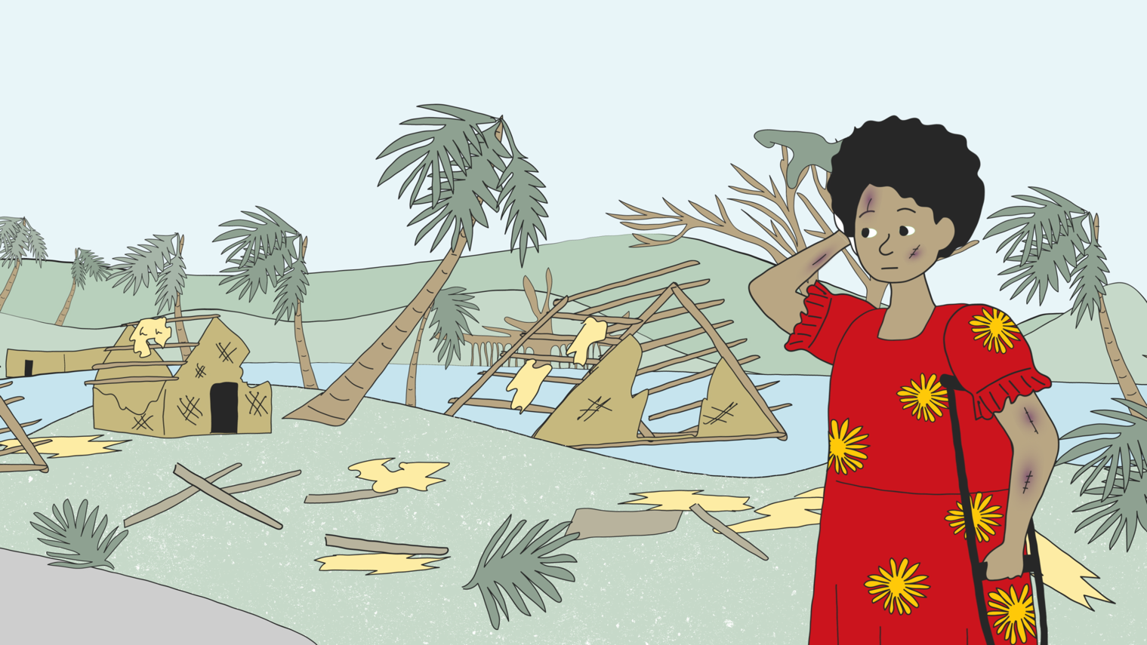

## Accessibility barriers within DRR programming

**Information on disaster preparedness is often not available in a range of accessible formats** **(such as pictorial, plain language, Braille, sign language, Easy Read, etc.)**.8

An in-depth study conducted by CBM Global’s Inclusion Advisory Group (IAG) during the period 2021 to 2022, gathered the experiences of over 860 people with disabilities, and revealed that people with disabilities experience substantial barriers when attempting to access critical disaster information, such as; early disaster warnings, evacuation center locations, news reports (television and radio), and community outreach.8 **People with disabilities routinely experience inadequate access to essential DRR information, despite having a higher need to access it**.

“We have a lot of typhoons here in the Philippines and of course I am not aware about that because I can’t hear anything on the news… The government will send out those SMS messages about disasters, but those messages are in Filipino, and I cannot understand Filipino, and so basically, whether it’s on television or the radio, or in whatever form, we get paranoid because we are the last to know whatever is going on. And so, I am really, really concerned about myself and what would happen if there was an emergency and we had to evacuate and what would happen to me as I will be the last to know”.8

Demonstrating ‘**proactive agency**’ (the ability to take initiative and action to address issues without waiting to be directed to do so) **the majority of people with disabilities (85.2%),8 reported having** **previously undertaken preparedness measures of their own accord in anticipation of future disaster events**.

An evaluation of disability inclusion within the DFAT-funded Australian Humanitarian Partnership [Disaster READY](https://australianhumanitarianpartnership.org/preparedness) program revealed that persistent attitudinal, environmental, communication and institutional barriers hinder the effectiveness of disability-inclusive DRR activities and impacts.[7] **The prevalence of stigma and negative attitudes towards disability emerged as a significant challenge** across all five countries in the study, representing a major barrier to embedding the active inclusion and participation of people with disabilities.

## Limited collection and use of disability data

**The absence of systematic disability data collection is a persistent issue across DRR programming.** **‘Systematic disability data collection’** refers to a process for collecting disability data using an organised method that is embedded within a program or activity.

A 2022 study by IAG in partnership with the Humanitarian Advisory Group, investigated the role of OPDs in disaster preparedness and response in the Pacific.14 It highlighted that **the lack of systematic disability data collection to monitor the inclusion of people with disabilities in DRR initiatives, is problematic**.[8]

The United Nations Office for Disaster Risk Reduction (UNDRR) advocates for the standardised collection and use of disability data. **When disability data is not collected, it results in an absence of people with disabilities in programming, leaving their heightened risks and the barriers to participation they face, unaddressed**. This further excludes those who are already struggling to be included.3

Although a few stakeholders do incorporate disability data into their DRR programming, it appears that they don’t have a solid grasp of how to utilise recommended tools such as The [Washington Group Questions](https://www.washingtongroup-disability.com/) – a globally relevant, standardised, disability data identification tool – effectively.[9] The Pacific Disability Forum (PDF) identified that **many NGOs persist in using disability screening questions, such as asking “do you have a disability?”, which can inadvertently discourage individuals from self-reporting due to the associated stigma,** or be confusing as functional limitations may be associated with age and not understood as a disability in many cultures and societies.9 12 This approach, when employed, has been shown to lead to a notable under-representation of disability within data sets.9 12

## What needs to change to progress disability inclusion?

DRR policymakers and implementing agencies are beginning to realise that **to create effective and inclusive disaster preparedness initiatives they must include people with disabilities** and seek to better comprehend the heightened risks and unique barriers they encounter.12

"People with disabilities are being used as a token, effectively we are there but that is only on paper… we want [them] to see we are not only a recipient, we'll be a contributor also, because we know better than anyone what we need, how we can contribute for our community… we want to see many people with disabilities are coming forward and treated as experts, treated as contributors, and we can work as a vital part of the disaster management process.”8 – Man with a disability from Bangladesh.

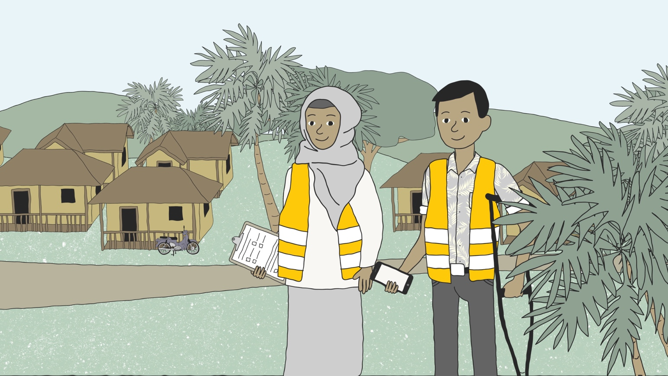

# Part 2: Recommendations from people with disabilities working in DIDRR

**This section shares good practice case studies that illustrate how DRR practitioners can effectively include people with disabilities in DRR.**

## Provide accessible environments and reasonable accommodations

As people with disabilities often experience barriers in society, it is essential to provide accessible environments and reasonable accommodations to ensure that people with disabilities can **participate and benefit equitably**.

** ‘Accessibility’** is about creating environments, services, products, and information in a way that can be **used for everyone**. Accessibility focuses on removing barriers to ensure everyone has equal access and equal opportunities to participate fully.

Examples of accessibility measures include:

* Building ramps and accessible bathrooms
* Including closed captions on videos
* Providing information in accessible formats, such as Easy Read, large print, or braille.

Whilst accessibility strives to create inclusive environments, there are situations where **accessibility measures may not fully address the needs of every individual with a disability**. Reasonable accommodations help to address this gap.

**‘Reasonable accommodations’** are provided on an individual basis, **to address the specific needs of a person with a disability.** Providing reasonable accommodations may include making specific adjustments to how a program, place, or activity is delivered, or by providing additional support to that person so they can participate equitably.

Examples of reasonable accommodations include:

* Providing accessible transport for people with disabilities
* Providing sign language interpreters or support persons (sometimes known as ‘personal assistants’)
* Enabling flexible participation in group settings.

This means that even if you are working on accessibility from the start, that reasonable accommodations will still need to be provided – as **each person with a disability has different needs.**

As the majority of countries have signed and ratified the UN CRPD, we have a **responsibility to provide accessible environments and reasonable accommodations** to ensure equal access and opportunities for people with disabilities.

Recommendation 1: Learn directly from OPDs about accessibility and reasonable accommodations

* Engage with an OPD to conduct a disability inclusion awareness-raising session on accessibility and reasonable accommodations.
* Learn about [**how to provide reasonable accommodations**](https://participation.cbm.org/in-practice/key-enablers/securing-ra) from CBM International.

Recommendation 2: Budget for reasonable accommodations

* When engaging with OPDs and people with disabilities, ensure there is a budget which covers the costs of providing reasonable accommodations, so they can participate in DRR activities equitably.

## Transforming policy into practice: the implementation of disability inclusion commitments within DRR policies

**It is vital to address the disconnect between policy commitments and their tangible realisation.**

“We had a volcanic eruption in the south [Ambae, Vanuatu] last year. We could see that people with disabilities are still being left out. Even though the government’s policy on climate change and disaster risk reduction is inclusive, it’s only on paper.”   
- Nelly Caleb, National Coordinator for the Vanuatu Disability Promotion and Advocacy Association.[10]

**It is important to ensure that DRR practitioners and program implementors are held accountable, using clear reporting mechanisms**. It is also critical to ensure that disability-inclusive DRR policy guidance is translated into actions at the local and community levels,12 ensuring that governments, NGOs and other key DRR stakeholders have adequate **budget** dedicated to making this possible.[11]

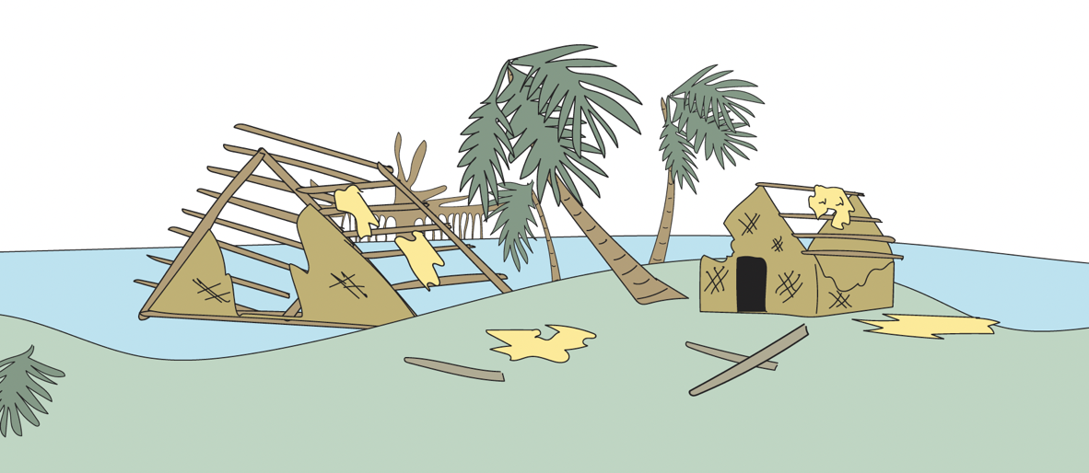

Case Study: Implementing inclusive policy in action in Indonesia

A good example of an inclusive DRR policy that has been embedded into practice is the Indonesian National Disaster Management Agency (Badan Nasional Penanggulangan Bencana (BNPB)) which issued Regulation No. 14/2014 regarding the involvement of people with disabilities in DRR,[12] as well as Law Number 24/2007 on Disaster Management.[13]

**This policy highlights the importance of ensuring people with disabilities are actively involved and can meaningfully participate in DRR efforts**. The Indonesian Disability Service Unit operates with the National Disaster Management Agency, BNPB, and its local offices, with a focus on integrating disability inclusion into BNPB’s disaster programming.[14]

The Disability Unit within the Indonesian Disaster Management Agency partners directly with OPDs at both provincial and district levels.21 **This involvement has proven effective in enhancing the implementation of inclusive DRR initiatives at the local level**, notably by raising awareness of disability inclusion and promoting the active participation of people with disabilities in DRR decision-making processes.22

The Government has collaborated with OPDs in activities such as the development of disaster contingency plans, simulation exercises, involvement in the protection cluster, and representation in the multi-stakeholder DRR forum.22 Across Indonesia, **there has been a noticeable increase in the engagement of people with disabilities in national DRR coordination activities**.22 In addition, the adoption of online and remote activities has expanded OPD participation, which has helped to overcome some previous accessibility barriers. Whilst the level of participation varies, OPDs across West, Central and East Indonesia have received comprehensive support on DIDRR, thanks to inclusive policies and investments made by BNPB.21 22

Recommendation 3: Sufficiently resource disability inclusion by establishing a disability budget within DRR policies and guiding frameworks.

* **A disability-inclusive budget** is specifically designed to fund the costs of reasonable accommodations, OPD engagement and remuneration,[15] and disability inclusion capacity-building initiatives for program staff.
* **Adequate resourcing**, such as embedding a disability budget of 3 to 5 % of total cost, **ensures that disability inclusion initiatives can be undertaken.**[16]
* Learn more on [**inclusive budgeting from CBM Global**](https://idrr.cbm.org/en/card/inclusive-budget).

Recommendation 4: Engage OPDs and people with disabilities in the development and implementation of disability activities within DRR policies.

* **OPDs can support** to provide realistic and achievable outcomes that align with the needs and priorities of people with disabilities.
* **DRR policies and strategies must be developed in collaboration with national OPDs, and people with disabilities** (more than one person) should be included in DRR policy committees.
* Learn more about[**meaningfully engaging with OPDs**](https://participation.cbm.org/supporting-material/additional-resources/practical-tips-for-working-with-organisations-of-persons-with-disability-opds)from CBM International.

Recommendation 5: Monitor policy implementation and accountability mechanisms.

* **Work with OPDs to establish clear and measurable disability inclusion indicators** within DRR policies to assess the extent to which disability inclusion objectives are being met.
* This can be achieved by **regularly collecting disability data and engaging with OPDs to periodically review and evaluate this data** to identify gaps and successes, and to adjust DRR policies accordingly.
* It is important to **involve OPDs and people with disabilities in developing inclusive feedback and accountability mechanisms,** where a culture of continuous improvement for disability inclusion is welcomed.
* Learn more about [**collecting and monitoring disability data**](https://www.did4all.com.au/Resources/Plan-CBM-Nossal_Disability-Data-Collection-Practice-Note_2016Update.pdf) from CBM Australia, Nossal & Plan International.

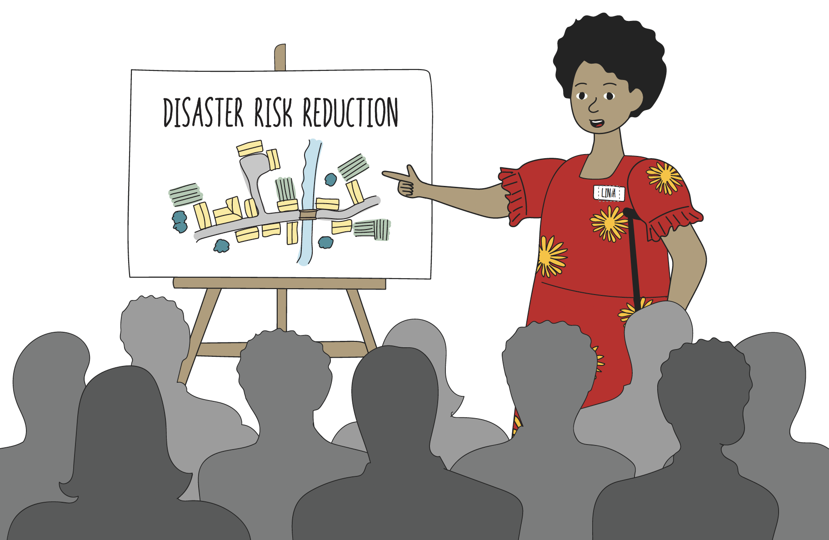

## Establishing long-term, mutually-beneficial partnerships with OPDs

The **‘Grand Bargain’** signifies a substantial **commitment** established between leading humanitarian agencies and donors across the world, with the primary objective of **enhancing the efficiency and effectiveness of humanitarian assistance**.25

Since 2016, the Grand Bargain has been **signed by over 60 donors and NGOs**, and it has had a significant impact on the way that humanitarian aid is delivered.25 Whilst it called for “organizations and donors to increase and support multi-year investment in the institutional capacities of local and national responders, including preparedness, response and coordination capacities” in 2017,[17] this has **not yet been achieved for disability inclusion.**12

“Humanitarian organisation needs to be intentional when integrating disability inclusion in their programs, which means it should be reflected from its initial planning phase [and] comes with its budget’s commitments.  We must dismantle all tokenistic approaches to achieve true and meaningful partnerships.” – Jay Nasilasila, Disability-Inclusive DRR Officer in Fiji with the Fiji Disabled Peoples Federation.[18]

It is imperative to recognise the pivotal role that OPDs play as vital stakeholders and change-makers in effective DIDRR.12 23 28 To truly leverage their expertise and lived experience, **partnerships with OPDs must be built on a foundation of active listening, understanding their unique needs and priorities**. It is by laying this essential foundation, that formal partnership agreements can become an effective mechanism to progress mutually-agreed and mutually-beneficial, shared objectives.[19] 12

These agreements should not be static, but rather **allow for ongoing consultation and harmonisation with OPDs, ensuring alignment with their evolving priorities and strategic plans**. Crucially, it is vital to understand OPDs' capacities and strengths, avoid unrealistic expectations, and maintain open dialogue for continuous improvement. This collaborative approach seeks to foster trust, and ultimately strengthen the collective impact of DIDRR initiatives.

“To have a successful engagement with an organisation partner, we should be included in their plans and activities in order to inform them on how to reach people with disabilities. [However] humanitarian organisations can only include OPDs in their activities until the end of their projects. It is therefore better for us to have our own funds so that it can go on with the programs and activities to focus on the people with disabilities.” - Staff member from Vanuatu Disability Promotion and Advocacy Association.12

In pursuit of meaningful partnerships, notable initiatives have emerged.[20] **The following case studies illustrate how strategic partnerships can drive transformative change** in disability-inclusive DRR.

Case Study: Establishing bi-directional capacity-building relationships with OPDs

The 2021 evaluation of disability inclusion within the Disaster READY program found that disability inclusion was stronger in NGO-led DRR programs where formal partnerships with OPDs had been developed.8 11

It found that in Timor-Leste and Fiji, engagement with OPDs goes beyond a box-ticking exercise and is a collaborative process to ensure that the important perspectives of OPDs representing the wider disability movement are captured.9 **NGOs Plan Fiji and Oxfam Timor-Leste have established bi-directional capacity development relationships with OPDs**.11 Their partnership approaches centre around a reciprocal exchange of support – where OPDs contribute to increasing the capacities of NGOs to implement DIDRR practices, whilst concurrently receiving organisational strengthening from the NGOs.11

Whilst still in its formative stages and ongoing refinement, the outcomes are so far significant. Notably, OPDs in Fiji and Timor-Leste have strengthened their skills as technical service providers of DIDRR,11 and the NGOs are better able to proactively and effectively embed disability inclusion throughout their program activities.11

Case Study: Promoting DIDRR through strategic partnerships in the Pacific

RedR Australia has developed strategic partnership agreements with OPDs in the Pacific,[21] to formalise their commitment to strengthening inclusive processes within DRR efforts. The strategic partnership agreements were formally ratified through the signing of new Memorandum of Understanding (MOUs) with Fiji Disabled Peoples Federation (FDPF) and the Disabled Peoples’ Association of Solomon Islands (DPASI).[22] It represents a shift towards a shared commitment to ensuring that people with disabilities are included in DRR efforts.

**“These are significant partnerships. They are the first MOUs we have signed with Organisations of Persons with Disabilities (OPDs) in the Pacific, and they represent agreements of mutual respect and understanding. These new partnerships enable the organisations to work together on equal footing. They are designed to strengthen the OPDs through technical support on disaster risk reduction activities and humanitarian response”.**30 - Jenny Lee, RedR Australia’s Director of Strategy and Partnerships.

These partnerships signify a shift in how DRR is, and can be, approached by **tapping into the expertise of OPDs** to drive transformational change.12

“Organisations get information from OPDs, then forget them or give them only a small amount of money to work with. Going forward, organisations need to sit with OPDs and talk and plan well with them. The partnership has to make [it] clear what each of them will do and how they will benefit from it. Transparency has to be on the table starting from the design stage.” – International NGO Partner, Vanuatu. 12

Recommendation 6: Develop formalised partnerships with OPDs that are mutually-beneficial

* Partnership agreements can be **formalised through written agreements**, such as a Memoranda of Understanding (MoU).
* These agreements should outline responsibilities, goals and outcomes for the partnership, including shared values.
* Incorporating partnership principles such as **‘two-way capacity-building’** can help to emphasise the imperatives and values of the partnership within a contract. These should be **monitored by both parties**, to ensure the partnership is not one-sided.

Recommendation 7: Provide capacity-strengthening for OPDs

* Whilst the increased recognition of OPDs’ capacity to lead and participate in disaster preparedness is positive, this must be **accompanied by adequate support for OPDs to fulfil their role.**
* Ensure that within a partnership agreement, there **are funds and technical assistance to account for capacity-strengthening requirements of OPD staff** to perform their roles, particularly when working on new topics or ways of working that require training or support.
* Learn more about the [**benefits of strengthening OPDs’ capacity**](https://cbm-global.org/wp-content/uploads/2022/02/CBM-Global-OPD-partnership-report_accessible-1.pdf) from CBM Global’s research.

Recommendation 8: Embed a flexible funding approach

* Given that the very nature of working in DRR means that disaster events can happen at any time, some without warning, **OPDs requires flexibility in funding arrangements** to facilitate their effective engagement in activities.12
* Therefore, rather than setting fee-for-service tasks, **embedding a flexible funding approach** has been identified as key to supporting OPDs’ work.12

## Mandating the collection of disability data across all DRR activities

The **lack of disability-disaggregated data and empirical evidence continues to be a significant barrier** to transforming commitments to disability-inclusive DRR into tangible, effective action.[23] It is important to collect, monitor and evaluate disability data within DRR programming. This not only gathers prevalence data on the number of people with disabilities or the different types of disabilities, **it is also an effective tool for understanding the barriers people face to participation, and the efforts required to remove them**.11

“Disability-disaggregated data is critical in ensuring that actions, policies, or procedures used by humanitarian actors are inclusive for people with disabilities. It's needed to ensure that persons with disabilities are not left behind.” – Jay Nasilasila, Disability-Inclusive DRR Officer in Fiji with the Fiji Disabled Peoples Federation.[24]

As such, the collection, monitoring, and effective use of disability disaggregated data should be an integral component of any DIDRR policy.

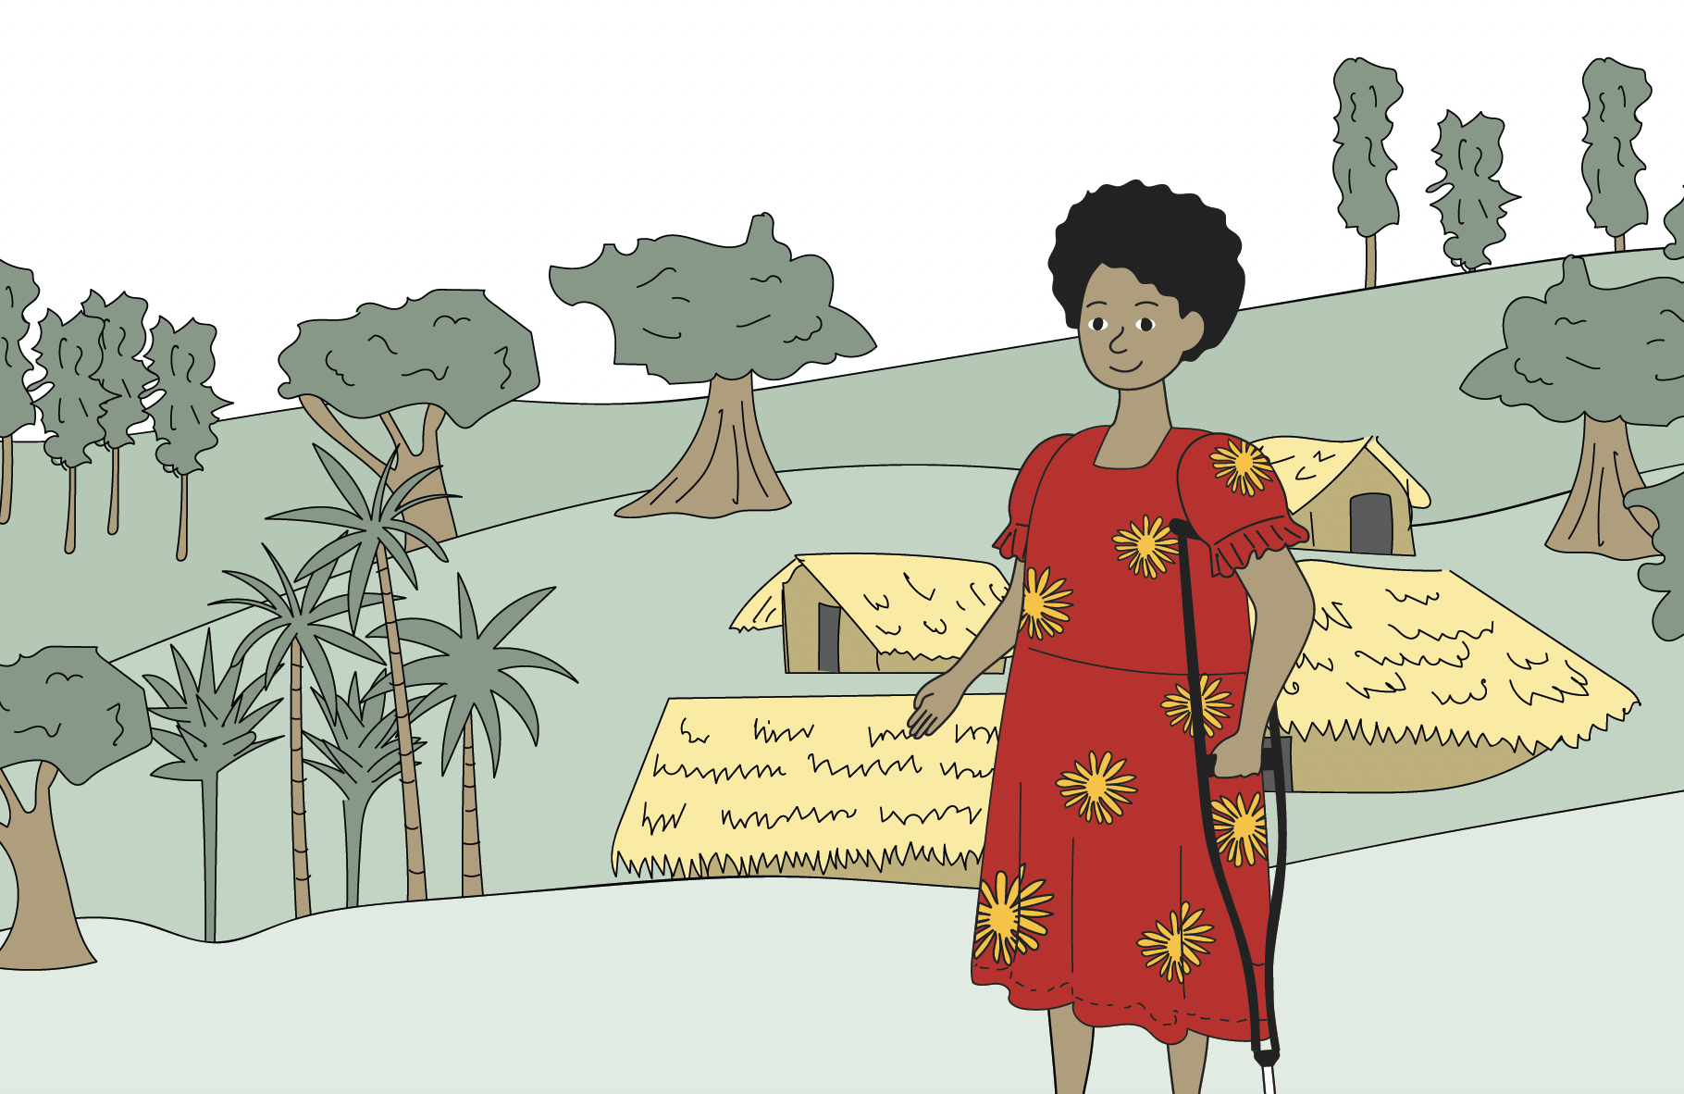

Case Study: OPDs leading disability data training for DRR programs in Timor-Leste

This case study demonstrates the **effective use of a systematic data collection tool to identify people with disabilities**, and what additional supports they may require to better prepare them for the disaster event.11

Timor-Leste’s national OPD, Ra’es Hadomi Timor Oan (**RHTO**), has provided Oxfam Timor-Leste with a **series of capacity-building trainings on disability data collection within a DRR context**. The collaboration began after the March 2020 Dili floods, making it the first disaster response that involved OPDs in Timor-Leste.[25] At this point, Oxfam and other NGOs had not yet received capacity development support on disability inclusion.

During the 2020 flood response, staff from RHTO supported disaster assessments with other NGOs and discovered that the **data record forms did not sufficiently capture the needs of people with disabilities**.33 The government’s rapid risk assessment measured disability prevalence data by asking “do you have a disability”, which, as mentioned, often leads to under-reporting of disability due to stigma. The form did not include any additional information regarding the types of disabilities, gender, or if respondents had any accessibility requirements or need for assistive devices.33

**RHTO staff advocated for more comprehensive disability data collection methods and tools**.33 They **introduced the Washington Group Questions** to the NGOs and government officials involved in the rapid disaster assessment. Going forward, the Washington Group Short Set **(WG-SS)** of questions has been used to identify people with disabilities, **alongside a checklist** which could be drawn upon and completed by anyone who identified as a person with one or more functional limitations, **to identify their accessibility requirements**.33

After the disaster response efforts had largely ceased, **RHTO partnered with Oxfam to develop a training of trainers package for NGOs across Timor-Leste on the use of the WG-SS**.[26] The aim was to raise awareness and build the capacity of NGOs to be able to more effectively identify people with disabilities in an acceptable way.34

As a result, when the April 2021 floods due to Cyclone Seroja spread havoc across Timor-Leste, **NGOs were better prepared to support people with disabilities**.11 34

Recommendation 9: Use the Washington Group Short Set Questions for all activities to measure how many people with disabilities have been engaged or participated

* The **Washington Group Questions** (WGQs) are a set of six questions regarding functionality, and are an **effective tool for collecting disability data** in a sensitive way.14 15
* When looking to capture more comprehensive data on the different types of disabilities, the **Washington Group Extended Set and the Enhanced Set can be utilised to better identify people with cognitive and psychosocial disabilities**.[27]
* Learn more about [**using the WGQs**](https://cbm-global.org/resource/learning-brief-disability-data-using-washington-group-questions) from CBM Global.

Recommendation 10: Commission OPDs to deliver disability data training

* It is vital that DRR actors are **trained on how to use the WGQs**, alongside other disability data tools, **by people who are experienced in disability data collection**.15 Their expertise should be drawn upon to avoid causing harm through ineffective data collection processes. Many OPDs provide training on using the WGQs, and it is recommended to **check if your local OPD provides this training**, if not, this may be an opportunity to seek additional disability inclusion advice.

Recommendation 11: Use the Incheon Indicators within M&E processes

* Incorporating the use of **disability indicators**, such as the disability-inclusive DRR indicators found in the **Incheon Strategy Goal 7**: Ensure disability-inclusive disaster risk reduction and management, can be utilised to **track progress** on DIDRR.5
* The Incheon Indicators can **assist in starting discussions on what types of disability indicators to develop** for a program or activity. These can then be **further refined with OPDs** to align with the specific needs and priorities of each country/region and its unique context.
* Learn more about the [disability-inclusive DRR indicators](https://www.google.com/url?sa=t&rct=j&q=&esrc=s&source=web&cd=&ved=2ahUKEwj5p7HLuvyEAxVZ6jgGHUaGCmwQFnoECBQQAQ&url=https%3A%2F%2Fwww.unescap.org%2Fsites%2Fdefault%2Ffiles%2FESCAP%2520Guide%2520on%2520Disability%2520Indicators.pdf&usg=AOvVaw2CMRNvIqffaZLBAzIJcMJn&opi=89978449) in the Incheon Strategy (pp. 52-57).

## Ensuring all DRR information is communicated in multiple accessible formats

**It is important to ensure that all people, including people with different types of disabilities, can access information equally.** This is particularly important when considering the widespread use of traditional early warning systems, which are often inaccessible.8

Given the diversity of disabilities, **there is often a need to produce different types of information**, such as Easy Read documents with pictures with [alt-text](https://www.visionaustralia.org/business-consulting/digital-access/blog/five-tips-for-writing-alt-text#:~:text=Alternative%20text%20or%20alt%2Dtext,that%20is%20communicated%20via%20images) and bolded font, or videos with sign language interpretation, closed captions, or audio descriptions.

“For persons with disabilities… there should be enough communication, which is accessible… for Deaf people as well. So, I would focus on communication accessibility of the information system.” – Participant from Nepal who participated in CBM IAG’s ‘Our Lessons’ research.8

Case study: Inclusive flood messaging in Timor-Leste

**CARE Timor-Leste supported the creation of community billboards outlining disaster risks** relating to the river, floods and strong winds. As flooding is common across Timor-Leste, it was important to ensure all people, including people with disabilities, were adequately informed. To ensure accessibility**, the billboards were designed and displayed in pictorial form – using pictures to demonstrate what to do before and during a disaster event.****[28]** This is not only accessible for people with disabilities who may need information in easy-to-understand formats, but also for people with low literacy levels, including children.

CARE Timor-Leste reported that communities residing in flood-prone areas evacuated to safety earlier than previously, during a recent flooding event.36

Case study: Fiji’s Disability Emergency Operations Centre

In 2019, the Fiji Disabled Peoples Federation (FDPF) and the Fiji National Council for Persons with Disabilities (FCDP) activated the **Disability Emergency Operations Centre** **(EOC)**.[29] Its purpose is to facilitate the sharing of information between the National Disaster Management Office (NDMO) and people with disabilities, during disaster events.[30]

Whilst primarily designed to establish inclusive disaster communications during disaster responses**, the Disability Emergency Operations Centre also plays a crucial role in disseminating disaster preparedness messages to people with disabilities across Fiji.**38

This outreach effort involves the set-up **of email notifications by a dedicated group of volunteers from Fijian OPDs to relay vital disaster warnings and information from the NDMO and meteorological services**.38 These messages are then **tailored to adhere to inclusive communications guidelines**, before being distributed through OPD community focal points that serve as liaisons within their respective communities, **directly conveying the information to people with disabilities.** A wide range of communications platforms are utilised to share this information, based on the communication requirements of the community members, such as; SMS, phone calls, emails, video conferencing with sign language, radio, and face-to-face interactions.38

**Furthermore, these OPD community focal points provide crucial feedback to the EOC, reporting on the status of people with disabilities within their community, and outlining any actions that will need to be taken to keep them safe during the disaster**.38 In addition, the Fiji Association of the Deaf (FAD), the Sign Language Interpreters Association Fiji, and peak OPD (FDPF) worked with the NDMO to **embed sign language interpretation for all NDMO disaster press conferences**.[31] [32]

During the disaster preparedness phase before Tropical Cyclone Yasa in 2020, the Fijian Disability Emergency Operations Centre **released sitreps that detailed the specific access requirements of people with disabilities**,38 based on the outcomes of successfully implementing the EOC. Members of the community focal points and DRR Resource Team also **attended cluster meetings to share the importance of disability-inclusive and accessible communications**.38 The effective use of accessible information sharing has proven to be **imperative** **in ensuring that people with disabilities are included** in essential disaster preparedness messaging.38

Recommendation 12: Produce written documents in accessible formats.

* Developing and disseminating **Easy Read versions of community-based DRR materials and embedding** [**alt-text**](https://www.visionaustralia.org/business-consulting/digital-access/blog/five-tips-for-writing-alt-text#:~:text=Alternative%20text%20or%20alt%2Dtext,that%20is%20communicated%20via%20images) **into online documents** can help to ensure that people with disabilities have equal opportunities to be informed and participate.
* Learn more about [**how to** **produce documents in accessible formats**](https://www.cbm.org/fileadmin/user_upload/Publications/CBM-Digital-Accessibility-Toolkit.pdf) from CBM’s Digital Accessibility Toolkit (Section 3).

Recommendation 13: Include sign language interpretation.

* Incorporate sign language interpretation, both in-person during live events such as news broadcasts, and through video for DRR training materials, or other video resources.

Recommendation 14: Use multiple avenues to make communication channels more accessible.

* **Use multiple platforms to ensure that disaster preparedness messaging and early warnings are disseminated** (e.g., posters, radio, SMS, etc). Social media can also be utilised as an effective platform to share messages.

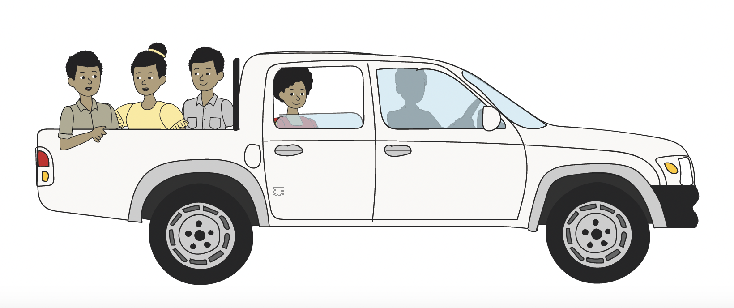

Discussion and Call to Action

These case studies highlight the crucial role of OPDs in driving effective, disability-inclusive DRR activities. While OPDs' active engagement is imperative, **it is equally vital that mainstream DRR actors—NGOs, governments, and others—take ownership of implementing a disability-inclusive approach**. This means not just consulting OPDs, but **actively integrating the needs and perspectives of people with disabilities into all aspects of DRR planning and implementation**, ensuring that the burden of driving inclusion doesn't fall solely on the shoulders of people with disabilities themselves.34 8 3 12

“Although NGOs include PWDSI on preparedness and response, NGOs are leaning on PWDSI (OPD) to lead their disability inclusion work.” – International NGO partner of PWDSI, now known as Disabled Peoples Association of Solomon Islands.12

People with disabilities are still excluded from DRR roles. **They continue to be labelled as a ‘vulnerable group’**,[33] or overlooked entirely due to barriers such as the stigma related to having a disability.[34] 8 Practitioners have spent too long defining people with disabilities and categorising them as ‘vulnerable’. Whilst well-intentioned, this inadvertently diminishes the intrinsic value of people with disabilities as human beings.[35] [36]

**The narrow focus on vulnerability has obscured a wider view**. People with disabilities are not merely passive recipients of assistance, **they are dynamic, passionate, and talented individuals with the capability to contribute meaningfully to DRR efforts,** particularly regarding their own risks and how to manage these.[37]

“People with disabilities are not more vulnerable to disasters, they experience exclusion from participation. People with disabilities have the knowledge, skills, and individual capacities to be able to prepare for, and respond to, disaster events but often experience heightened risks which arise from social exclusion and existing barriers… It is these gaps in capacity which equate to vulnerability, not the outdated charity model of disability which labels people with disabilities as inherently vulnerable.” – CBM Global’s research on disability and disasters8

It is time to recognise that **disability is not synonymous with helplessness.** Whilst not underestimating the challenges that people with disabilities face due to inaccessible environments, **their strengths and unique perspectives have gone untapped for far too long.**8

It is essential for DRR practitioners, NGOs, and other key stakeholders to learn about, and understand, that people with disabilities are capable of deeply engaging in DRR processes, and that people with disabilities are not just beneficiaries or target groups, but leaders and decision-makers.

1. World Health Organization. 2022. ‘Global report on health equity of persons with disabilities’. Available at: <https://www.who.int/publications/i/item/9789240063600>
2. Fujii, K. 2012. ‘The Great East Japan Earthquake and Disabled Persons’, in Disability Information Resources, Japan. Available at: <https://www.dinf.ne.jp/doc/english/twg/escap_121031/fujii.html>
3. CBM Global Inclusion Advisory Group 2022. ‘Our Lessons: An Approach to Disability-Inclusive Disaster Risk Reduction – based on the consultations of people with disabilities in the Asia and Pacific regions’. Available at: <https://www.cbm.org.au/resource/our-lessons-disability-inclusive-disaster-risk-reduction-report#:~:text=To%20help%20disability%2Dinclusive%20disaster,the%20perspectives%2C%20experiences%20and%20priorities>
4. Robinson, A. 2017. ‘Disability inclusion and disaster risk: principles and guidance for implementing the Sendai Framework’. Available at: <http://did4all.com.au/resources/Robinson_2017_Disability_Inclusion_and_Disaster_Risk_Implementing_Sendai.pdf>
5. Sparf, J. 2016. ‘Disability and Vulnerability: Interpretations of Risk in Everyday Life’. Journal of Contingencies and Crisis Management, Vol, 24: pp. 244-252. <https://doi.org/10.1111/1468-5973.12120>
6. UNDRR (formerly UNISDR). 2014. ‘Living with Disability and Disasters’. United Nations Office for Disaster Risk Reduction. Available at: <https://www.unisdr.org/2014/iddr/documents/2013DisabilitySurveryReport_030714.pdf>
7. Baker, S. 2021. ‘Disability Inclusion in Disaster Preparedness and Response: An evaluation of disability inclusion in the Disaster READY program in Fiji, Vanuatu, Solomon Islands, Papua New Guinea and Timor-Leste’. Available at: <https://ahp1.squarespace.com/s/Evaluation_DIinDR_Accessible-Format.pdf>
8. CBM Global Inclusion Advisory Group. 2022. ‘Organisations of Persons with Disabilities: Making a Difference in Vanuatu and Solomon Islands’. Available at: <https://cbm-global.org/wp-content/uploads/2022/06/OPD-making-difference-vanuatu-solomon-islands.pdf>
9. Sloman, A, M, Margaretha. 2018. ‘The Washington Group Short Set of Questions on Disability in Disaster Risk Reduction and humanitarian action: Lessons from practice’. International Journal of Disaster Risk Reduction. Vol 31, pp. 995-1003. DOI: <https://doi.org/10.1016/j.ijdrr.2018.08.011>
10. UNDRR. 2022. ‘Women leaders in DRR working for inclusion’. Available at: <https://www.preventionweb.net/blog/women-leaders-drr-working-inclusion>
11. UNDRR. 2022. ‘Gender responsive and disability inclusive early actions in the Pacific region.’ Available at: <https://wrd.unwomen.org/sites/default/files/2022-07/73853_summary%20sendaipacificbrieffinal.pdf>
12. ASEAN Studies Centre. 2020. ‘Indonesian National Law and Policy Report: Displacement in the Context of Disasters and Climate Change’. Available at: <https://disasterdisplacement.org/wp-content/uploads/2021/08/Indonesia-Displacement-Law-and-Policy-Brief_English.pdf>
13. Badan Nasional Penanggulangan Bencana (BNPB). 2022. ‘Official Statement of the Indonesian Delegation: 2022 Asia-Pacific Ministerial Conference on Disaster Risk Reduction’. Available at: <https://reliefweb.int/attachments/c3c95f97-0651-4c30-9d25-72a1baf210c5/DiDRR%20Study%20in%20English.pdf>
14. DiDRRN. 2022. ‘Including Persons with Disabilities in Disaster Risk Reduction: A Research Study from Eight Countries of Africa, Asia and South/Central America’. Available at: <https://apmcdrr.undrr.org/sites/default/files/inline-files/Indonesia_Statement_APMCDRR%202022.pdf>
15. Pertiwi, P, Llewellyn, G & Villeneuve, M. 2019. ‘People with disabilities as key actors in community-based disaster risk reduction’. Disability & Society. Vol. 34. Pp. 1419-1444. DOI: 10.1080/09687599.2019.1584092
16. DFAT. 2021. ‘Disability Inclusion Good Practice Note’. Australian Department of Foreign Affairs and Trade. Available at: <https://www.dfat.gov.au/sites/default/files/disability-inclusive-development-guidance-note.pdf>
17. ICVA. 2017. ‘The Grand Bargain Briefing Paper’. Available at: <https://www.icvanetwork.org/uploads/2021/08/Topic-Six-Grand-Bargain-Explained-ICVA-Briefing-Paper.pdf>
18. CARE. 2023. ‘Fiji Humanitarian Landscape evolving to embrace Inclusion and Intersectionality: Leave No One Behind’. Available at: <https://reliefweb.int/report/fiji/fiji-humanitarian-landscape-evolving-embrace-inclusion-and-intersectionality-leave-no-one-behind>
19. CBM Global. 2022. ‘Policy Paper: Disability-Inclusive Climate Action’. Available at: <https://www.cbmuk.org.uk/wp-content/uploads/2022/04/CBM-Policy-Paper-Disability-Inclusive-Climate-Action-March-2022.pdf>
20. Villeneuve, M. 2020. ‘Building a roadmap for inclusive disaster risk reduction in Australian communities’. Progress in Disaster Science. Vol. 10. DOI: <http://dx.doi.org/10.1016/j.pdisas.2021.100166>
21. CBM Australia. 2023. ‘Driving Disability-Inclusive Humanitarian Action with RedR Australia’. Available at: <https://www.cbm.org.au/stories/driving-disability-inclusive-humanitarian-action-redr-australia>
22. RedR Australia. 2023. ‘Two new partnerships: working towards more inclusive societies in the Pacific’. Available at: <https://www.redr.org.au/news-and-publications/latest-news/two-new-partnerships-working-towards-more-inclusive-societies-in-the-pacific/>
23. CBM-Nossal. 2017. ‘Disability inclusion in disaster risk reduction in the Pacific: Policy Brief’. Available at: <https://mspgh.unimelb.edu.au/__data/assets/pdf_file/0018/2508210/Nossal-DIRR-Policy-Brief-2017-WEB.PDF>
24. Pacific Resilience Partnership (PRP). 2021. Facebook post 6 July 2021. Available at: <https://www.facebook.com/PacificResiliencePartnership/posts/jay-nasilasila-the-ahp-disaster-ready-drr-officer-with-fiji-disabled-peoples-fed/2965430557060835/>
25. RHTO. 2021. ‘Disability Inclusion in the Rapid Disaster Assessment during the Dili Floods – March 2020’. Ra’es Hadomi Timor Oan. Available at: <https://australianhumanitarianpartnership.org/knowledge-hub/dili-floods-2020-disability-inclusion-in-the-rapid-needs-assessment>
26. DFAT. 2023. ‘Disaster READY Timor-Leste: Phase 1 Completion Report 2017-2022’. The Australian Department of Foreign Trade and Affairs. Available at: <https://australianhumanitarianpartnership.org/ahp-and-disaster-ready-annual-reports/c90qjxlftzqfz6z2j5e4tz9l1gbhgu>
27. UNFPA Asia Pacific. 2021. ‘A brief explainer on The Washington Group Questions on Disability’. United Nations Population Fund Asia Pacific. Available at: <https://asiapacific.unfpa.org/en/publications/brief-explainer-washington-group-questions-disability>
28. CARE. 2022. ‘With a surge of natural disasters in Timor-Leste, women’s leadership helps save lives’. Available at: <https://www.care.org.au/blog/womens-leadership-helps-save-lives-eng/>
29. Shifting the Power Coalition. 2020. 'Mobilizing Inclusive Disaster Preparedness and Response: TC Yasa'. Available at: <https://www.facebook.com/shiftingthepowercoalition/photos/a.2263809880552057/2740912142841826/?paipv=0&eav=AfZIWUYxTzWlgBX7F7UPkOTOnJDeKTE-ZwhitsNB6_D4E1Z0Eobg-a0lYjeREmJgWHg&_rdr>
30. United Nations Office for Disaster Risk Reduction (UNDRR). 2021. 'Inclusive and Accessible Multi-Hazard Early-Warning Systems: Learning from Women-Led Early-Warning Systems in the Pacific'. Available at: <https://www.undrr.org/publication/inclusive-and-accessible-multi-hazard-early-warning-systems-learning-women-led-early>
31. ABC Pacific. 2020. 'Disability advocate hails introduction of sign language translation to Fiji cyclone updates'. Available at: <https://www.abc.net.au/pacific/programs/pacificbeat/disability-disasters-fiji-ndmo-cyclone-tino-sign-language/11884886>
32. Disaster READY. 2023. 'Disaster READY Fiji: Phase 1 Completion Report'. Australian Humanitarian Partnership. Available at: <https://australianhumanitarianpartnership.org/ahp-and-disaster-ready-annual-reports/n87mwy4nb8k3nh4scfjkgmv84de4zk>
33. Abbot, D and Porter, S. 2013. ‘Environmental Hazard and Disabled People: From Vulnerable to Expert to Interconnected’. *Disability & Society*. Vol. 28, No. 6. DOI: <https://doi.org/10.1080/09687599.2013.802222>
34. King, J, Edwards, N, Watling, H, and Hair, S. 2019. ‘Barriers to disability-inclusive disaster management in the Solomon Islands: Perspectives of people with disability’. International Journal of Disaster Risk Reduction. Vol 34, pp 459-466. DOI: <https://doi.org/10.1016/j.ijdrr.2018.12.017>
35. Pertiwi, P, Llewellyn, G and Villeneuve, M. 2020. ‘Disability representation in Indonesian disaster risk reduction regulatory frameworks’. International Journal of Disaster Risk Reduction. Vol.45. DOI: <https://doi.org/10.1016/j.ijdrr.2019.101454>
36. Kusumowardoyo, C and Tamtomo, K. 2022. ‘Reflection on implementing the Sendai Framework in the Asia-Pacific: beyond adding disability inclusion to disaster risk reduction’. Disasters. Vol. 46, No. 4. DOI: 10.1111/disa.12507
37. Centre for Disability Research and Policy. 2016. ‘Disability and DRR/Emergency Preparedness: Scoping Review’. University of Sydney, NSW. Available at: <https://www.unisdr.org/preventionweb/files/54807_didpscopenov16.pdf>